

QUARTERLY SECTOR STATISTICS REPORT

SECOND QUARTER OF THE FINANCIAL YEAR 2012/13

(OCT-DEC 2012)

Direct any questions on this report to:
Director/Competition, Tariffs and Market Analysis
Tel:+254-703 042000
Email: info@cck.go.ke
Website: www.cck.go.ke

Disclaimer:
Although every effort has been made to ensure accuracy of the data contained in this report, the Commission is not liable for the inaccuracy of the information, which is contingent to the operators’/service providers’ compliance returns.

TABLE OF CONTENTS

List of Tables 3
List of Figures 4
List of Abbreviations 5
I. PRELIMINARY NOTES 6
II. THE QUARTER IN SUMMARY 6
1 CELLULAR MOBILE SERVICES 8
1.1 Subscriptions 8
1.2 Mobile Money Transfer Service 11
1.3 Mobile Number Portability 11
1.4 Mobile Traffic and Usage Pattern 12
1.4.1 Voice Traffic 12
1.4.2 Voice Traffic by Operator 13
1.4.3 Minutes of Use 14
1.4.4 Roaming Traffic 16
1.4.5 International Mobile Traffic 17
1.5 Mobile Revenue and Investments 17
2 FIXED TELEPHONE SERVICE 18
1.1 Subscriptions 18
1.2 Fixed Network Traffic 18
3 DATA AND INTERNET SERVICE 20
3.1 Internet/Data Service 20
3.2 Broadband Service 22
3.3 International Bandwidth 23
3.4 Revenue and Investment in the Data/Internet Market 24
4 ELECTRONIC TRANSACTIONS 25
5 BROADCASTING 25
6 POSTAL AND COURIER SERVICE 25
6.1 Postal and Courier Traffic 25
6.2 Number of Postal Outlets 26
6.3 Postal and Courier Revenue and Investment 26
7 CONCLUSION 30

List of Tables

Table 1: Mobile Subscriptions 8
Table 2: Mobile Subscriptions per Operator 9
Table 3: Mobile Money Transfer 11
Table 4: Number of Inports 12
Table 5: Local Mobile Voice Traffic in Minutes 12
Table 6: Voice Traffic by Operator 14
Table 7: Short Messaging Service 15
Table 8: Multimedia Messaging Service 16
Table 9: Roaming Traffic 16
Table 10: International Mobile Traffic (Minutes) 17
Table 11: Mobile Revenue and Investment (KES) 18
Table 12: Fixed Network Subscriptions 18
Table 13: Local Fixed Network Traffic in Minutes 19
Table 14: Internet Subscriptions and Internet Users 20
Table 15: Mobile Data/Internet Subscriptions by Operator 21
Table 16: Other Fixed/Wireless Internet Subscriptions by Operator 22
Table 17: International Internet Available Bandwidth (Mbps) 23
Table 18: International Internet Connectivity Bandwidth (Mbps) 23
Table 19: Data/Internet Revenue and Investment 24
Table 20: Number of Domain Names 25
Table 22: Postal and Courier Traffic 26
Table 23: Number of Postal Outlets 26
Table 24: Postal and Courier Revenue and Investments 26

List of Figures

Figure 1: Net Additions in Mobile Subscriptions 9
Figure 2: Percentage Subscription Market Share per Operator 10
Figure 3: Mobile Penetration (%) 11
Figure 4: Growth in Mobile Traffic in Minutes 13
Figure 5: Minutes of Use per Subscriber per Month 14
Figure 6: International fixed line network traffic 19
Figure 7: Estimated Number of Internet Users and Internet Penetration 21
Figure 8: Broadband Subscriptions 23

List of Abbreviations

ICTs  EASSy  EVDO  GSM  LION2 | Information Communication Technologies  Eastern Africa Submarine Cable System  Evolution-Data Optimized  Global Systems for Mobile Communications  Lower Indian Ocean Network
Mbps  MMS | Megabits per second  Multimedia Service
MoU  SEACOM | Minutes of Use  Sea Sub-Marine Communications Limited
SIM | Subscriber Identification Module
SMS | Short Messaging Service
TEAMS The East African Marine System
VSAT Very Small Aperture Terminal

PRELIMINARY NOTES

- This report is based on data provided by service providers.
- The information in this report is subject to alteration in case of any revisions or updates from the service providers.

THE QUARTER IN SUMMARY

At the end of Quarter 2 of the 2012/13 financial year, a total of 30.7 million subscribers were registered on the mobile network representing a marginal growth of 1.0 percent from the last quarter. - Mobile penetration stood at 78.0 percent during the period up from 77.2 percent recorded during the previous period.

The number of pre-paid subscribers continued to dominate the total mobile subscriptions accounting for 99.0 percent. During the quarter under review, there were 30.4 million pre-paid subscribers up from 30.1 million recorded in the previous quarter, representing a 1.0 percent growth. Likewise post-paid subscribers grew by 1.6 percent during the period to reach 302,403.

Total local mobile traffic grew by 4.9 percent during the period to stand at 7.3 billion minutes up from 7.0 billion minutes recorded during the previous period. Compared to the same period of the previous year, an increase of 9.6 percent was recorded. In addition, the Minutes of Use (MoU) per subscriber per month grew by 3.9 percent to reach 79.7 minutes from 76.9 recorded during the previous period. Similarly, the total number of SMS was recorded at 3.6 billion up from 1.0 billion recorded during the previous period, representing a three-fold increase during the quarter. This growth was occasioned by the increase in SMS bundles reported by Safaricom Limited during the period. Each subscriber sent an average of 40.1 SMS per month during the period.

The fixed line network recorded a marginal growth of 1.3 percent during the period to reach 251,576 lines. This growth was brought about by a 4.5 percent increase in the subscriptions of the fixed wireless services from 177,910 to 185,857 during the quarter under review. The fixed terrestrial lines however declined to 65,710 from 70,390 lines recorded during the previous period, representing a 6.6 percent drop.

In the Internet/data market segment, the number of subscriptions rose by 11.5 percent during the period to reach 9.4 million from 8.5 million recorded during the previous quarter. Compared to the same period of the previous year, there was an increase of 75.1 percent. Mobile data/internet continued to dominate the internet market contributing 99.0 percent of the total Internet/data subscriptions. The number of estimated internet users was recorded at 16.2 million up from 14.5 million posted the previous quarter, representing an increase of 11.6 percent during the period. Internet penetration went up by 4.3 percentage points to reach 41.1 percent up from 36.8 percent during the previous period. The number of broadband subscribers declined by 0.3 percent during the period to stand at 1,002,701 down from 1,006,071 posted during the previous period. The decline is attributed to a reduction in the number of fixed terrestrial broadband subscribers.

The tremendous growth in the Internet/data market segment may be attributed to international internet connectivity (used) bandwidth that has continued to spiral upwards. During the quarter under review the international internet used bandwidth stood at 328,641 Mbps up from 278,329 Mbps posted during the previous period, a rise of 18.1 percent. The total available bandwidth in the country was recorded as 906,186 Mbps during the quarter. Thus, the used bandwidth represented 36.3 percent of the total available bandwidth capacity.

In the postal and courier sector, the number of letters sent locally declined by 2.0 percent to reach 17.3 million down from 17.7 million letters sent during the previous period. Compared to the same period of the previous year, a decline of 11.8 percent was recorded. However, the number of international incoming letters grew by 20.9 percent during the period to reach 191,672 letters from 158,549 received during the previous period. Similarly international outgoing letters reached 1.9 million from 1.6 million during the previous period, representing 18.1 percent increase.

The number of postal outlets shrunk by 4.9 percent during the period to reach 634outlets down from 667 recorded during the previous quarter.

CELLULAR MOBILE SERVICES

Subscriptions

During the period under review (Quarter 2 of the Financial Year 2012/2013), the total number of mobile subscribers rose to 30.7 million up from 30.4 million recorded in the previous quarter. This represents an increase of 1.0 percent during the period and 13.9 percent compared to the same period of the previous year.

However, as observed during the previous period, the rate of growth has slowed down as the market appears saturated and tending towards maturity.

The growth of mobile subscriptions is shown in Table 1.

Table 1: Mobile Subscriptions
Subscription Type | Dec-12 | Sep-12 | Quarterly  Variation (%) | Dec-11 | Quarterly Variation (%)
Prepaid Subscriptions | 30,429,351 | 30,135,142 | 1.0 | 26,744,335 | 13.8
Post-Paid Subscriptions | 302,403 | 297,640 | 1.6 | 236,436 | 27.9
Total Mobile Subscriptions | 30,731,754 | 30,432,782 | 1.0 | 26,980,771 | 13.9
Source: CCK, Operators’ Returns

The number of pre-paid subscribers grew by a similar margin to the total number of mobile subscriptions of 1.0 percent during the period while that of post-paid subscribers posted a 1.6 percent growth during the period. Both pre-paid and post-paid subscriptions recorded growth of 13.8 percent and 27.9 percent respectively compared to the same period of the previous year. As has been the trend, the number of pre-paid subscribers continued to dominate the mobile telephony sector, accounting for 99 percent of mobile subscriptions.

Unlike the previous period that recorded growth in the total net additions, the quarter under review recorded a decline of 59.0 percent to post 298,972 new subscribers down from 729,343 recorded during the previous period. Compared to the same period of the previous period, a decrease of 81.2 percent was recorded.

The growth in total additions is shown in Figure 1.

Figure 1: Net Additions in Mobile Subscriptions
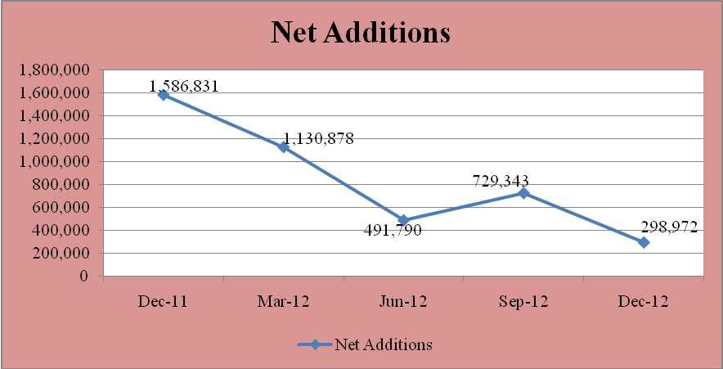
Source: CCK, Operators’ Returns.

During the review period, three mobile operators recorded positive gains in subscriptions. Safaricom Limited gained 593,036 new subscribers, representing a growth of 3.1 percent. Essar Telecom Limited gained 223,974 new subscribers (7.5%) while Airtel Networks Kenya Limited signed up 91,283 subscribers, representing an increase of 1.8 percent of new subscriptions. On the other hand, Telkom Kenya (Orange) lost 609,321 subscribers, representing a decline of 19.7 percent.

The mobile subscription by operator is shown in Table 2.

Table 2: Mobile Subscriptions per Operator
Name of operator | Dec-12 |  |  | Sep-12 |  |  | Quarterly  Variation (%)
Name of operator | Pre-paid | Post-paid | Total | Pre-paid | Post-paid | Total | Quarterly  Variation (%)
Safaricom Limited | 19,621,431 | 192,814 | 19,814,245 | 19,045,713 | 175,496 | 19,221,209 | 3.1
Airtel Networks Kenya Limited | 5,101,480 | 103,799 | 5,205,279 | 4,997,807 | 116,189 | 5,113,996 | 1.8
Essar Telecom Kenya Limited | 3,225,753 | 1,519 | 3,227,272 | 3,001,808 | 1,490 | 3,003,298 | 7.5
Telkom Kenya Limited (Orange) | 2,480,687 | 4,271 | 2,484,958 | 3,089,814 | 4,465 | 3,094,279 | -19.7
Total | 30,429,351 | 302,403 | 30,731,754 | 30,135,142 | 297,640 | 30,432,782 | 1.0
Source: CCK, Operators’ Returns

The market share as measured by the number of subscribers witnessed marginal change over the period. Safaricom Limited gained 1.3 percentage points to record a market share of 64.5 percent up from 63.2 percent recorded during the previous period. Essar Telecom Kenya Ltd’s market share by subscribers grew to 10.5 per cent, representing an increase of 0.6 percentage points up from 9.9 percent recorded during the previous period. Airtel Networks Limited gained 0.1 percentage points to record 16.9 percent from 16.8 percent in the previous quarter as Telkom Kenya (Orange) lost 2.1 percentage points to record a market share by subscribers of 8.1 percent down from 10.2 percent posted in the previous quarter.

The market share by subscription by operator is shown in Figure 2.

Figure 2: Percentage Subscription Market Share per Operator
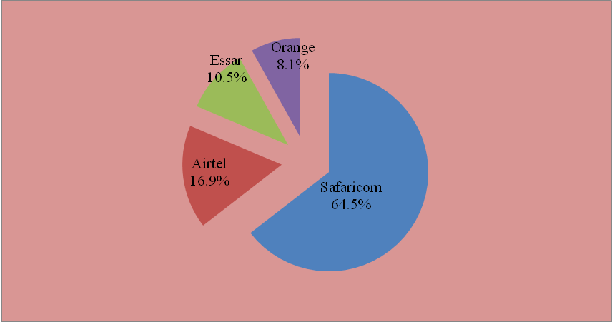
Source: CCK, Operators’ Returns

During the period under review, the population that had access to mobile telephony services continued to record positive growth. In this regard, mobile penetration increasedto78.0 per 100 inhabitants up from 77.2 recorded during the previous quarter. This represented a quarterly increase of 0.8 percentage points, compared to the same period of the previous year that recorded an increase of 6.7 percent. .

The growth trend in the mobile penetration is shown in Figure 3.

Figure 3: Mobile Penetration (%)
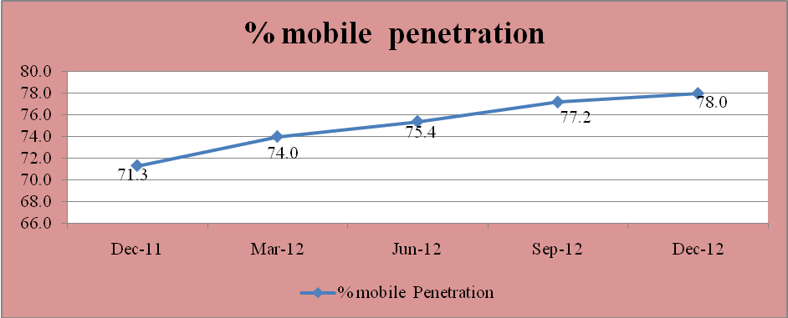
Source: CCK, Operators’ Returns

Mobile Money Transfer Service

As shown in Table 3, the mobile money transfer service continued to record tremendous growth during the period. The number of mobile money transfer subscribers grew by 9.4 percent to 21.1 million up from 19.3 million recorded in the previous period. Similarly, the total deposits grew by 10.3 percent to 226 billion up from 205 billion recorded during the previous period.

Table 3: Mobile Money Transfer
Mobile Money  Transfer | Dec-12* | Sep-12 | Quarterly  Variation (%) | Q2 FY 2011/12 | Quarterly Variation (%)
Subscriptions | 21,140,808 | 19,318,684 | 9.4 | 18,981,443 | 11.4
No. of Agents | 62,300 | 54,409 | 14.5 | 47,997 | 29.8
Total Deposits (KES) | 226,762,319,504 | 205,665,717,834 | 10.3 | 176,836,359,552 | 28.2
Source: CCK, Operators’ Returns

In the same way, the number of active agents increased to 62,300 up from 54,409 recorded during the previous quarter, representing an increase of 14.5 percent. This growth signifies increased accessibility of mobile money transfer service as well as more employment opportunities for the youth.

Mobile Number Portability

The number of ports registered in the Mobile Number Portability (MNP) service increased significantly from 217 in-ports recorded during the previous period to 375 in-ports posted during the period under review. This represents an increase of 72.8 percent but a decline of 84.4 percent compared to the same period of the previous year.

Table 4: Number of In-ports
Period | Oct-Dec 12 | Jul-Sep 12 | Apr-Jun-12 | Jan-Mar-12 | Oct-Dec-11
Number of In-ports | 375 | 217 | 678 | 6,646 | 2,407
Variation (%) | 72.8 | -68.0 | -89.8 | 176.1 | 24.8
Source: CCK, Operators Returns

Although there was growth during the period, the uptake of the service was still low. This could be attributed to reduced tariff differentials among operators, long porting duration experienced by the porting customers, prevalent use of multiple SIM cards as well as consumer preferences and choice.

Mobile Traffic and Usage Pattern

Voice Traffic

A total of 7.3 billion minutes were made on the mobile network during the period up from 7.0 billion minutes the previous quarter, representing an increase of 4.9 percent.. Compared to the same period of the previous year, an increase of 9.6 percent was recorded. The mobile traffic increase could have been spurred by increased promotions and special offers and the festive season that fell within the quarter. The promotions and offers extended by the operators included 25 percent bonus airtime for recharge above KES 100, special calling rate to subscribers within specified areas and 50 percent free airtime for each recharge done through the money transfer service.

As Table 5 shows, on-net traffic grew by 4.1percent during the period from 6.0 billion minutes recorded during the previous period to 6.2 billion minutes recorded during the period under review.Similarly, off-net traffic increased by 9.1 percent from 947 million minutes recorded during the previous period to 1.0 billion minutes posted during the period under review. A 30.9 percent increase was posted compared to the same period of the previous year.

Table 5: Local Mobile Voice Traffic in Minutes
Mobile Traffic | Oct-Dec 12* | Jul-Sep 12 | Quarterly Variation (%) | Oct-Dec 11 | Quarterly Variation (%)
By traffic Origination(Outgoing traffic)
Own Network –Own Network | 6,294,040,711 | 6,043,845,857 | 4.1 | 5,870,570,860 | 7.2
Own Network to Other Mobile Networks | 1,033,150,168 | 947,394,800 | 9.1 | 789,197,560 | 30.9
Mobile Network to Fixed Network | 20,247,929 | 14,044,125 | 44.2 | 42,171,413 | -52.0
Total Traffic Origination (Outgoing) | 7,347,438,808 | 7,005,284,782 | 4.9 | 6,701,939,833 | 9.6
By Traffic Termination (Incoming traffic)
Own Network –Own Network | 6,294,040,711 | 6,043,845,857 | 4.1 | 5,870,570,860 | 7.2
Other Mobile Networks to Own Network | 1,075,133,317 | 1,000,397,283 | 7.5 | 839,328,628 | 28.1
Fixed Network to Mobile Network | 30,623,414 | 24,879,357 | 23.1 | 32,281,989.00 | -5.1
Total Traffic Termination (Incoming Traffic) | 7,399,797,442 | 7,069,122,497 | 4.7 | 6,742,181,477 | 9.8

Source: CCK, Operators’ Returns

Mobile-to-fixed traffic went up by 44.2 percent to record 20.2 million minutes up from 14.0 million minutes posted during the previous quarter. However, a 52.0 percent drop was recorded compared to the same period of the previous year.

With regard to traffic by termination, the total number of voice minutes received on all mobile networks increased by 4.7 percent to 7.3 billion minutes during the period from 7.0 billion minutes recorded during the previous period. Similarly, a 9.8 percent growth was recorded compared to the same period of the previous year.

As illustrated in Figure 4, the ratio of on-net traffic to total traffic declined by 0.6 percentage points to record 85.7 percent while the ratio of off-net traffic increased by 0.6 percentage points to record 14.3 percent from 13.7 percent the previous quarter.

Figure 4: Growth in Mobile Traffic in Minutes
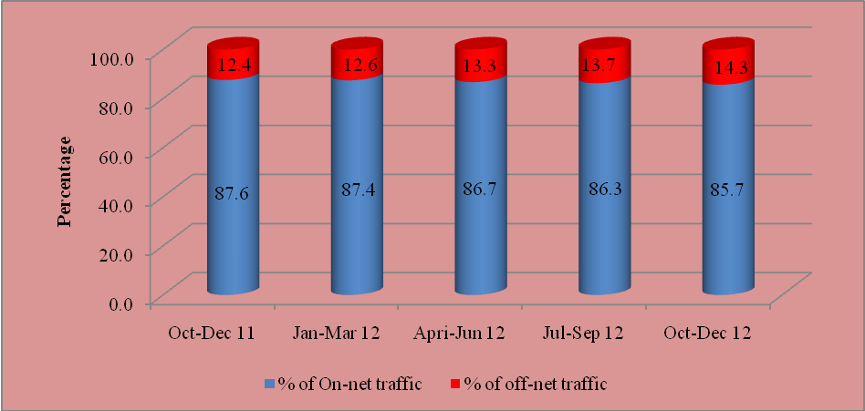
Source: CCK, Operators’ Returns

Voice Traffic by Operator

As witnessed during the last quarter, the market shares by traffic recorded marginal change during the period with Safaricom Limited posting 77.5 percent up from 76.7 percent recorded during the previous period. This represented an increase in market shares of 0.8 percentage points. Telkom’s (Orange) market share by traffic went up to 1.4 per cent up from 1.1 per cent recorded during the previous quarter; represent a gain of 0.3 percentage points. However, Essar Telecom Limited lost 1.0 percentage points to record 8.6 percent market share by traffic down from 9.6 percent recorded during the previous period. Airtel Networks Kenya Limited remained unchanged with 12.5 percent market share.

Voice traffic and resultant market share by operator are shown in Table 6.

Table 6: Voice Traffic by Operator
Period | Name of Operator/Indicator | Safaricom Limited | Airtel Networks Kenya Limited | Essar Telecom Kenya Limited | Telkom Kenya Limited (Orange)
Oct-Dec 12 | On-net | 5,376,302,861 | 391,376,604 | 474,309,791 | 52,051,455
Oct-Dec 12 | Off-net | 320,199,542 | 527,185,652 | 157,656,337 | 48,356,566
Oct-Dec 12 | Total | 5,696,502,403 | 918,562,256 | 631,966,128 | 100,408,021
Oct-Dec 12 | Market Share (%) | 77.5 | 12.5 | 8.6 | 1.4
Jul-Sep 12 | On-net | 5,092,967,502 | 385,690,177 | 519,000,275 | 46,187,903
Jul-Sep 12 | Off-net | 281,943,508 | 492,476,715 | 155,886,263.2 | 31,132,439
Jul-Sep 12 | Total | 5,374,911,010 | 878,166,892 | 674,886,538 | 77,320,342
Jul-Sep 12 | Market Share (%) | 76.7 | 12.5 | 9.6 | 1.1
Source: CCK, Operators’ Returns

Minutes of Use

During the quarter under review, the number of Minutes of Use (MoU) per subscriber per month reached 79.7 up from 76.7 minutes recorded during the previous period, representing a 3.9 percent growth. This growth could be attributed to promotions and special offers by the operators during the period and the resultant increase in voice traffic among subscribers. However, compared to the same period of the previous year, a decline of 0.3 percent was recorded.

Figure 5: Minutes of Use per Subscriber per Month
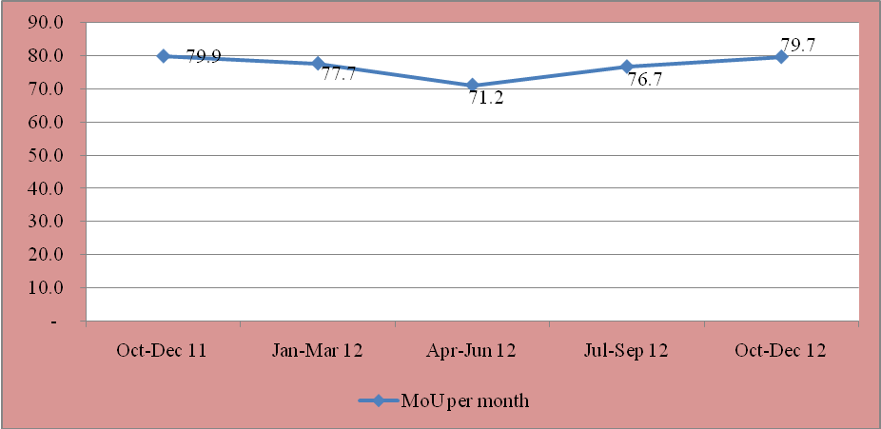
Source: CCK, Operators’ Returns

During the quarter, 3.6 billion SMS were sent up from 1.0 billion SMS sent during the previous period. This three-fold increase may have been fuelled by high service use during the festive season.

There were 3.4 billion on-net SMS recorded during the period up from 906 million SMS during the previous period, representing a three-fold increase. Off-net SMS traffic grew by 21.3 percent during the period to record 218 million SMS from 179 million recorded during the previous period. The growth in SMS traffic could be attributed to the reduced prices as the Communications Commission of Kenya (CCK) continued to implement the SMS termination rates glide path. Currently, the off-net termination rate is KES 0.10 per SMS. In addition, with significant reduction in voice tariffs and the attendant revenues, operators are now focusing on non-traditional revenue sources, including data.

As shown in Table 7, the market shares by SMS exhibited a wide disparity among the operators over the period. This is particularly so for on-net and off-net where the difference is significantly distinct. During the quarter in review, Safaricom Limited recorded the highest market share by SMS traffic at 93.7 percent up from 80.3 percent during the previous quarter, representing growth of 13.4 percentage points. Airtel Networks Limited’s market share by SMS declined to 4.5 percent from 14.8 percent recorded during the previous period representing a decline of 10.3 percentage points. Essar Telecom Limited’s market share by SMS declined by 2.1 percentage points to reach 1.2 percent from 3.3 percent recorded in the previous quarter. Telkom Kenya (Orange) had 0.6 percent market share by SMS during the period from 1.6 percent posted during the previous period. The significant growth in market share by Safaricom Limited could have partially offset the decline in market shares by the other operators during the period.

Table 7: Short Messaging Service
Period | Name of Operator/Indicator | Safaricom Limited | Airtel Networks Kenya Limited | Essar Telecom Kenya Limited | Telkom Kenya Limited (Orange) | Total SMS
Oct-Dec 12 | On-net | 3,362,382,350 | 92,940,200 | 14,181,871 | 5,476,700 | 3,474,981,121
Oct-Dec 12 | Off-net | 98,746,630 | 71,615,403 | 29,898,319 | 18,085,900 | 218,346,252
Oct-Dec 12 | Total | 3,461,128,980 | 164,555,603 | 44,080,190 | 17,528,578 | 3,693,327,373
Oct-Dec 12 | Market Share (%) | 93.7 | 4.5 | 1.2 | 0.6
Jul-Sep 12 | On-net | 800,374,308 | 90,875,738 | 9,656,255 | 5,198,721 | 906,105,022
Jul-Sep 12 | Off-net | 71,841,705 | 70,077,000 | 25,746,989 .2 | 12,329,857 | 179,995,551
Jul-Sep 12 | Total | 872,216,013 | 160,952,738 | 35,403,244 | 17,528,578 | 1,086,100,573
Jul-Sep 12 | Market Share (%) | 80.3 | 14.8 | 3.3 | 1.6
Source: CCK, Operators’ Returns

The number of Multi-Media Messages (MMS) sent during the quarter under review increased marginally by 2.5 percent to record 2,657,592 messages up from 2,593,638 recorded during the previous quarter. A 54.2 percent growth was recorded compared to the same period of the previous year.

Table 8: Multimedia Messaging Service
MMS Traffic | Oct-Dec 12 | Jul-Sep 12 | Quarterly Variation (%) | Oct-Dec 11 | Quarterly Variation (%)
MMS | 2,657,592 | 2,593,638 | 2.5 | 1,723,544 | 54.2
MMS per Subscriber per Month | 0.03 | 0.02 | 50.0 | 0.02 | 50.2
Source: CCK, Operators’ Returns

During the review period, the use of MMS service experienced slow growth, as the number of MMS sent by each subscriber per month remained below 1%. . The low uptake of this service could be attributed to customers’ preference to similar services offered by the social media.

Roaming Traffic
The total number of roaming out voice traffic rose to 11.6 million during the quarter under review, up from 11.4 million minutes posted the previous quarter, representing a growth of 2.1 percent. However, a decline of 60.6 percent was recorded compared to the same period the previous year.

Similarly, the number of roaming in voice traffic increased to 12.3million minutes during the period up from 10.9 million minutes recorded during the previous period. This represented a growth of 13.2 percent during the review period. Compared to the same period of the previous year, 107.0 percent growth was recorded as shown in Table 9.

Table 9: Roaming Traffic
Roaming Traffic | Oct-Dec 12 | Jul-Sep 12 | Quarterly Variation (%) | Oct-Dec 11 | Quarterly  Variation (%)
Roaming Voice Minutes Own Subscribers on Foreign Networks | 11,662,645 | 11,418,310 | 2.1 | 29,609,552 | -60.6
Roaming Voice Minutes Foreign Subscribers on Local Network | 12,391,655 | 10,943,964 | 13.2 | 5,986,703 | 107.0
Roaming SMS - Own Subscribers on Foreign Networks | 10,227,055 | 8,642,305 | 18.3 | 6,625,691 | 54.4
Roaming SMS - Foreign Subscribers on Local Network | 14,892,715 | 13,303,626 | 11.9 | 7,726,050 | 92.8
Source: CCK, Operators’ Returns

In addition, the number of roaming out SMS increased by 18.3 percent during the period to reach 10.2 million SMS up from 8.6 million SMS in the previous period. Notably, the growth in the number of roaming out SMS was higher than that of voice, an indication that out roamers preferred the SMS service to voice calls, achieving a 54.4 percent increase compared to the same period of the previous year.

Similarly, roaming in messages grew by 11.9 percent to reach 14.8 million up from 13.3 million messages recorded during the previous period. A significant growth trend was observed in the same period the previous year during which a 92.8 percent growth was recorded.

International Mobile Traffic

On its part, international incoming traffic grew marginally by 2.7 percent during the period to record 204 million minutes from 199 million minutes recorded during the previous period. Compared to the same period of the previous year, an increase of 33.4 percent was recorded.

On the other hand, international outgoing traffic dropped by 1.9 percent to 152 million minutes from 155 million minutes recorded during the previous period. This decline could have been partially offset by the growth in international incoming traffic during the period. However compared to the same period of the previous year, a 3.1 percent growth was recorded.

The number of international incoming mobile SMS similarly declined by 8.7 percent to reach 14.6 million down from 16.0 million recorded during the previous period. During the same period of the previous year, traffic dropped by 40.2 percent. There was however significant growth in international outgoing SMS of 51.6 percent from 5.9 million SMS posted during the previous period to 9.0 million SMS during the period under review. The international mobile voice traffic and SMS are shown in Table 10.

Table 10: International Mobile Traffic (Minutes)
International Mobile Traffic and SMS | Oct-Dec 12 | Jul-Sep 12 | Quarterly Variation (%) | Oct-Dec 11 | Quarterly  Variation (%)
International Incoming Mobile Voice Minutes | 204,955,902 | 199,661,993 | 2.7 | 153,664,018 | 33.4
International Outgoing Mobile Minutes | 152,774,194 | 155,745,313 | -1.9 | 148,164,029 | 3.1
International Incoming Mobile SMS | 14,679,764 | 16,073,120 | -8.7 | 24,545,535 | -40.2
International Outgoing Mobile SMS | 9,063,577 | 5,977,012 | 51.6 | 3,594,638 | 152.1
Source: CCK, Operators’ Returns

Mobile Revenue and Investments

Annual revenues and investments for the mobile industry have consistently grown over the last five years as indicated in Table 11.Revenue and investment data for year 2012 will be updated once mobile operators file their audited accounts at the end of their respective financial years.

Table 11: Mobile Revenue and Investment (KES)
Mobile Revenues and Investments | 2011** | 2010 | 2009 | 2008 | 2007 | Variation (%) Over 2010 | Variation (%) Over 2009 | Variation (%) Over 2008 | Variation (%) Over 2007
Mobile Revenue (KES Millions) | 116,640* | 104,552* | 90,394* | 72,625 | 57,998 | 11.6 | 29.0 | 60.6 | 101.1
Mobile Investments (KES Millions) | 34,590* | 27,126* | 40,260* | 29,436 | 21,221 | 27.5 | -14.1 | 17.5 | 63.0
Source: CCK, Operators Returns, (*) includes Telkom Fixed Network Revenue and Investment. ** (provisional)

FIXED TELEPHONE SERVICE

Subscriptions

The total number of fixed lines subscribers grew marginally by 1.3 percent during the review period to 251,567 lines up from 248,300 recorded during the previous period. This increase was boosted by a 4.5% growth in the number of fixed wireless subscribers during the period to reach 185,857.. However, the fixed terrestrial subscribers continued to drop recording a decline of 6.6 percent from 70,390 lines recorded during the previous period to 65,710 lines during the period under review. The increase in fixed wireless subscriptions could have partially offset the decline in fixed terrestrial subscriptions.

The growth of fixed line is shown in Table 12.

Table 12: Fixed Network Subscriptions
Fixed Network Subscription | Dec-12 | Sep-12 | Quarterly Variation (%) | Dec-11 | Annual  Variation (%)
Fixed Terrestrial Subscriptions | 65,710 | 70,390 | -6.6 | 90,814 | -27.6
Fixed Wireless Subscriptions | 185,857 | 177,910 | 4.5 | 192,732 | -3.6
Total Main Fixed Line Subscriptions | 251,567 | 248,300 | 1.3 | 283,546 | -11.2
Source: CCK, Operators’ Returns

Fixed Network Traffic

As shown in Table 13, the total number of minutes recorded in the fixed line network grew by 20.3 percent during the period to reach 53 million minutes up from 44 million minutes recorded during the previous quarter. This growth was driven by intra-network traffic that grew by 45.2 percent during the period also as a result of increased fixed wireless subscriptions during the period. The total fixed line traffic recorded 4.2 percent growth compared to the same period of the previous year.

Table 13: Local Fixed Network Traffic in Minutes
Local Fixed Network Traffic | Jul-Dec 12 | Jul-Sep-12 | Quarterly Variation (%) | Jul-Sep 11 | Quarterly variation (%)
Intra-Network Traffic(Fixed-Fixed) | 28,083,525 | 19,341,468 | 45.2 | 18,799,971 | 49.4
Fixed to Other Network (Mobile and LLOs) | 25,238,552 | 24,976,911 | 1.0 | 32,380,687 | -22.1
Total Local Fixed Network Traffic | 53,322,077 | 44,318,379 | 20.3 | 51,180,658 | 4.2
Source: CCK, Operators’ Returns

As Figure 6 illustrates, international voice traffic declined during the period under review. International incoming voice traffic decreased by 10.8 percent while international outgoing traffic declined by 13.2 percent during the period.

Figure 6: International fixed line network traffic
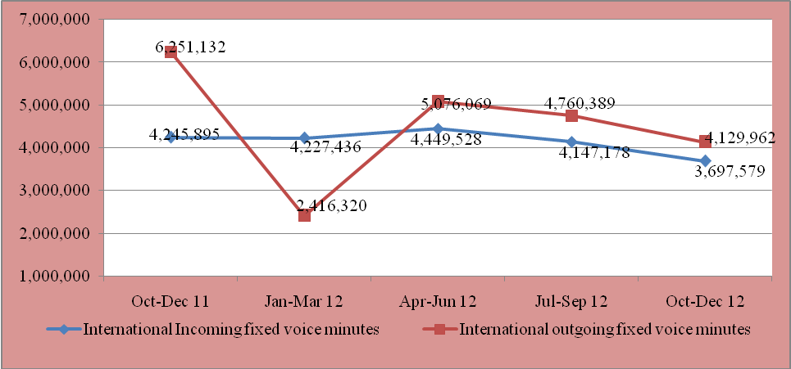
Source: CCK, Operators’ Returns

DATA AND INTERNET SERVICE

Internet/Data Service

There were 9.49 million internet subscribers at the end of the quarter under review up from 8.51 million recorded during the previous period. This represents an increase of 11.5 percent during the period and 75.1 percent increase relative to the same period in the previous year.

The mobile data/internet subscribers continued to dominate the internet, representing 99 percent of the total subscriptions. In addition, the quarter recorded 9.40 million mobile/data subscribers up from 8.43 million recorded during the previous period, representing a growth of 11.5 percent. This growth indicates operators’ aggressiveness to grow their respective market share through promotions and special offers during the period. For instance one operator offered reduced bundle rate for data by 50 percent from KES8 charged previously to KES4. This move could have influenced the increase in the number of mobile data/internet subscribers.

Similarly, the number of satellite subscribers grew by 28.8 percent from 531 to 684 the previous period. The growth could be attributed to operators’ willingness to offer an always on service particularly during down times of other networks such as fibre. Compared to the same period of the previous year, there was a recorded decline of 15.7 percent.

In addition, the number of fibre subscribers grew by 14.8 percent to 54,400 during the period up from 47,392 the previous period. Compared to the same period of the previous year, an increase of 142 percent was recorded, indicating an increased roll-out of fibre network in the country.

The growth in internet subscriptions is shown in Table 14.

Table 14: Internet Subscriptions and Internet Users
Internet/Data Subscriptions | Dec-12 | Sep-12 | Quarterly  Variation (%) | Dec-11 | Annual  Variation (%)
Total Internet Subscriptions | 9,496,573 | 8,519,148* | 11.5 | 5,423,428 | 75.1
Mobile Data/Internet Subscriptions | 9,406,843 | 8,436,578 | 11.5 | 5,376,050 | 75.0
Terrestrial Wireless Data/Internet Subscriptions | 23,814 | 23,780 | 0.1 | 13,059 | 82.4
Satellite Data/Internet Subscriptions | 684 | 531 | 28.8 | 811 | -15.7
Fixed DSL Data/Internet Subscriptions | 10,807 | 10,842 | -0.3 | 11,016 | -1.9
Fixed Fibre Optic Data/Internet Subscriptions | 54,400 | 47,392 | 14.8 | 22,467 | 142.1
Fixed Cable Modem Subscriptions | 25 | 25 | 0.0 | 25 | 0.0
Total Internet Users | 16,236,583 | 14,553,378 | 11.6 | 8,936,165 | 81.7
Source: CCK, Operators’ Returns, *Revision in data from Kenya Data Networks

At the end of the quarter under review, the estimated number of Internet users rose by 11.6 percent to reach 16.2million from 14.5million users in the previous quarter. This increase is attributed to growing demand for Internet and data services, including use of social media especially among the youth. Competitive tariffs by the mobile operators could also have contributed to the growth in the number of Internet users.

As Figure 7 illustrates, the quarter under review recorded growth of 4.3 percentage points of the people with access to the internet to reach 41.1 percent up from 36.8 percent in the previous period. An increase of 18.4 percentage points was recorded compared to the same period of the previous year.

Figure 7: Estimated Number of Internet Users and Internet Penetration
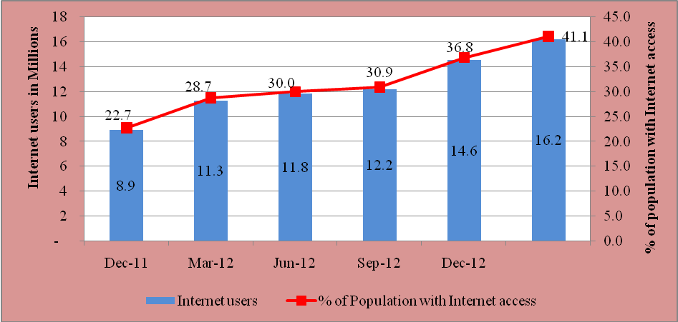
Source: CCK, Operators’ Returns

The level of concentration as measured by market share by subscription in the mobile data/Internet market segment changed for the four mobile operators during the period. Safaricom Limited increased its market share by subscription to 72.6 percent during the quarter, representing a growth of 6.4 percentage points. Airtel Networks Kenya Limited’s market share by subscription dropped to 11.7 percent from 15.1 percent, posting a decline of 3.4 percentage points during the period. Telkom Kenya’s (Orange) market share by subscription was at 9.1 percent while that of Essar Telecom Limited dropped from 7.4 percent recorded during the previous period to 6.7 percent share during the period under review. The mobile data/Internet subscriptions by operator are shown in Table 15.

Table 15: Mobile Data/Internet Subscriptions by Operator
Name of Operator | Dec-12 | Market Share (%) | Sep-12 | Market Share (%)
Safaricom Limited | 6,830,796 | 72.6 | 5,586,050 | 66.2
Airtel Networks Kenya Limited | 1,095,945 | 11.7 | 1,278,013 | 15.1
Telkom Kenya Limited (Orange) | 853,962 | 9.1 | 948,847 | 11.2
Essar Telecom Kenya Limited | 626,140 | 6.7 | 623,668 | 7.4
Source: CCK, Operators’ Returns

With regard to market share by other fixed/terrestrial wireless data/Internet subscriptions, Wananchi Telecom Limited recorded the highest at 31.8 percent down from 36.1 percent in the previous period. Kenya Data Networks followed with 28.9 percent. Access Kenya Limited had a market share of 12.9 percent down from 14.6 percent in the previous period. The market shares per operator are shown in Table 16.

Table 16: Other Fixed/Wireless Internet Subscriptions by Operator
Name of Operator | Dec-12 | Market Share (%) | Sep-12 | Market Share (%)
Wananchi Telecom Limited | 28,579 | 31.8 | 28,770 | 36.1
Kenya Data Networks Limited | 25,930 | 28.9 | 17,805 | 22.3
Access Kenya Limited | 11,600 | 12.9 | 11,600 | 14.6
Telkom Kenya Limited | 10,012 | 11.2 | 9,670 | 12.1
Safaricom Limited | 7,874 | 8.8 | 6,718 | 8.4
Jamii Telecommunication Limited | 1,779 | 2.0 | 1,470 | 1.8
Swift Global | 1050 | 1.2 | 1050 | 1.3
Call Key Networks Limited | 584 | 0.7 | 390 | 0.5
Tangerine Limited | 350 | 0.3 | 350 | 0.4
Pwani Telecomms | 271 | 0.3 | - | -
Other fixed/Terrestrial wireless operators | 1,701 | 1.9 | 1,867 | 2.3
Source: CCK, Operators’ Returns

Broadband Service

As Figure 8 illustrates, the total number of broadband subscribers was 1,002,701 down from 1,006,071 recorded during the previous period, representing a decline of 0.3 percent during the period under review. The marginal decline was contributed by a corresponding decline in fixed terrestrial broadband subscriptions during the period. However, compared to the same period of the previous year, more than seven-fold increase was recorded. Figure 8 shows the growth of broadband subscriptions over the period.

Figure 8: Broadband Subscriptions
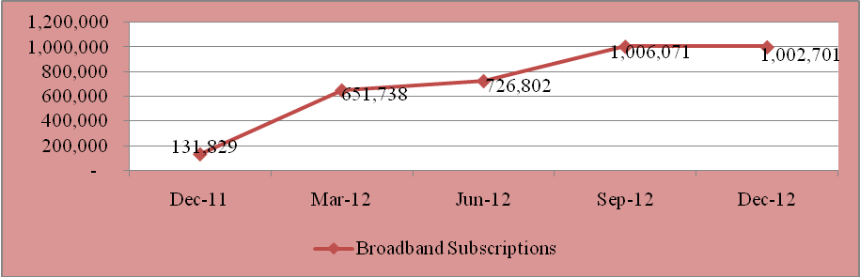
Source: CCK, Operators’ Returns.

International Bandwidth

By the end of the quarter under review, the total amount of bandwidth available in the country was 906,186Mbps up from 576,186 Mbps posted in the previous period. This represents a three-fold increase compared to the same period the previous year. The growth of international internet capacity may have been driven by the growing demand for data services in the country. The information on available international internet bandwidth is shown in Table 17.

Table 17: International Internet Available Bandwidth (Mbps)
International Connectivity Bandwidth | Dec-12 | Sep-12 | Quarterly  Variation (%) | Sep-11 | Annual  Variation (%)
SEACOM-International Internet Capacity (Mbps) | 640,000 | 310,000 | 106.5 | 210,000 | 204.8
TEAMS - International Internet Capacity (Mbps)* | 101,990 | 101,990 | 0.0 | 101,990 | 0.0
Telkom Kenya Limited (EASSY)* | 122,880 | 122,880 | 0.0 | 122,880 | 0.0
Lion 2* | 40,960 | 40,960 | 0.0 |  | -
VSAT | 355.8 | 355.8 | 0.0 | 649.78 | -45.2
Total International Internet Bandwidth (Mbps) | 906,186 | 576,186 | 57.3 | 435,520 | 108.1
Source: CCK, Operators’ Returns; (*) Provisional

The continued growth in the number of internet subscribers has positively impacted on the demand for internet bandwidth and consequently the growth of bandwidth usage in the country. During the quarter under review, the total used bandwidth in the country stood at 328,641 Mbps up from 278,329 Mbps recorded during the previous quarter. As shown in Table 18, this growth is particularly driven by capacity from fibre optic undersea cables.

Table 18: International Internet Connectivity Bandwidth (Mbps)
International Leased Bandwidth | Dec-12 | Sep-12 | Quarterly  Variation (%) | Dec-11 | Annual  Variation (%)
International Undersea Internet Connectivity Bandwidth (Mbps) | 328,483 | 278,171 | 18.1 | 52,830 | 521.8
International Satellite Internet Connectivity Bandwidth | 157.78 | 157.78 | 0.0 | 108.28 | 32.6
Total International Internet Connectivity Bandwidth (Mbps) | 328,641 | 278,329 | 18.1 | 52,938 | 520.8
Source: CCK, Operators’ Returns

Revenue and Investment in the Data/Internet Market

Revenue and investment data for year 2012 will be updated once data/internet operators file their audited accounts at the end of their respective financial years. However, where updates will be received before the end of the financial year, the data will be revised accordingly. Table 19 shows data on revenue and investments from 2007 to 2011.

Table 19: Data/Internet Revenue and Investment
Data/Internet Revenue  and Investments* | 2011** | 2010 | 2009 | 2008 | 2007 | Variation (%) Over 2010 | Variation (%) Over 2009 | Variation (%) Over 2008 | Variation (%) Over 2007
Data/Internet Revenue  (KES Millions) | 98,415 | 148,033 | 145,800 | 7,595 | 7,370 | -33.5 | -32.5 | 1195.8 | 1235.4
Data/Internet Investments  (KES Millions) | 26,456 | 29,361 | 53,870 | 1,171 | 833 | -9.9 | -50.9 | 2159.3 | 3076.0
Source: CCK, Operators’ Returns. * Note that revenue in data market is not inclusive of data revenues from mobile sector. ** Provisional.

ELECTRONIC TRANSACTIONS
During the quarter under review, there were 24,983 active registered domain names up from 22,589 domain names registered during the previous period, representing an increase of 9.6 percent during the period. Compared to the same period of the previous year, an increase of 76.8 percent was recorded. The growth in the number of domain names is shown in Table 20.

Table 20: Number of Domain Names
Period | Dec12 | Sep 12 | Jun 12 | Mar 12 | Dec 11
Number of Domain Names registered | 24,983 | 22,589 | 20,085 | 17,173 | 14,131
Variation (%) | 9.6 | 12.5 | 17.0 | 21.5 | 9.9
Source: Kenya Network Information Centre (KeNIC)

BROADCASTING

At the end of June 2012, there were 99 radio and 16 television stations licensed to offer broadcasting services.

POSTAL AND COURIER SERVICE

Postal and Courier Traffic

A total of 17.3 million letters were sent during the quarter under review down from 17.7 million letters posted in the previous period. This represents a decline of 2.0 percent during the period and 11.8 percent drop compared to the same period the previous year.

Similarly, the number of courier items sent during the period declined by 1.4 percent to 175,982 down from 178,443 items the previous period. The number dropped to 178,443 items from 398,724 sent during the previous period, representing a 55.2 percent decline. Likewise, compared to the same period in the previous year, a decline of 54.3 percent was recorded.

On the other hand, the number of international incoming letters went up by 20.9 percent to reach 191,672 from 158,549 letters posted during the previous quarter. Compared to the same period of the previous year, an increase of 13.9 percent was recorded.

Similarly, the number of international outgoing letters increased by 18.1 percent from1.6 million sent during the previous period to 1.9 million sent during the period under review. There was, however, decline in international outgoing traffic of 11.3 percent during the same period of the previous year.

The postal and courier traffic is shown in Table 21.

Table 21: Postal and Courier Traffic
Post and Courier Traffic | Oct-Dec 12 | Jul-Sep 12 | Quarterly Variation (%) | Oct-Dec 11 | Quarterly Variation (%)
Number of Letters Posted Locally | 17,386,730 | 17,733,334 | -2.0 | 19,718,326 | -11.8
Total Courier Items Sent Locally | 175,982 | 178,443 | -1.4 | 385,414 | -54.3
International Incoming Letters | 191,672 | 158,549 | 20.9 | 80,217 | 13.9
International Outgoing Letters | 1,990,920 | 1,685,620 | 18.1 | 2,244,615 | -11.3
Source: CCK, Operators’ Returns

Number of Postal Outlets

The number of postal outlets went down by 4.9 percent during the period under review to reach 634 outlets up from 667 recorded in the previous period. Compared to the same period of the previous year, a decline of 8.1 percent was recorded. The number of postal outlets over the period is shown in Table 21.

Table 22: Number of Postal Outlets
Period | Dec12 | Sep 12 | Jun 12 | Mar 12 | Dec 11
Postal Outlets | 634 | 667 | 667 | 690 | 690
Variation (%) | -4.9 | 0.0 | -3.3 | 0 | 0
Source: CCK, Operators’ Returns

Postal and Courier Revenue and Investment

Revenue and investment data for year 2012 will be updated once postal and courier operators file their audited accounts at the end of their respective financial years. However, where updates will be received before the end of the financial year, the data will be revised accordingly. Table 23 shows data on revenue and investments from 2007 to 2011.

Table 23: Postal and Courier Revenue and Investments
Post/Courier Revenue and Investment | 2011 | 2010 | 2009 | 2008 | 2007 | Variation (%) Over 2010 | Variation (%) Over 2009 | Variation (%) Over 2008 | Variation (%) Over 2007
Revenue (KES Millions) | 6,094 | 5,815 | 4,255 | 13,907 | 13,719 | 4.8 | 43.2 | -56.2 | -55.6
Investments (KES Millions) | 222 | 335 | 558 | 798 | 521 | -33.7 | -60.2 | -72.2 | -57.4
Source: CCK, Operators’ Returns

CONCLUSION

There has been remarkable growth in the ICT sector during the period driven largely by mobile voice and data services as demonstrated by the growing number of subscribers and mobile phone traffic. This growth is expected to be sustained but at a much lower pace. Mobile money transfer services continue to drive the usage of ICTs as seen by the high volume of financial transactions.

The data/internet market grew both in subscriptions and the number of internet users with the mobile data/internet segment posting the largest share. This is the sub-sector that provides the greatest opportunity to service providers considering the relatively low subscriber levels which promises a much more substantial growth rate compared to voice.

The total bandwidth available in the country stood at 906,186 Mbps with utilisation of 36.3 percent during the period. The creation of county governments and expected economic growth at the devolved levels should increase the use of ICTs and subsequent utilisation of available capacity.

The postal market is on a downward trend as evidenced by the decline in postal traffic of local letters sent and reduced number of postal outlets reported during the period. Deliberate measures such as national addressing system to facilitate delivery of letters to the doorsteps, diversification into financial services and wireless internet services across postal outlets among others could reverse this trend and revitalise the sector as happened in most developed countries.
Published: April, 2013
Author: CCK

The reduction in number of internet subscriptions was a result of revision in data for Kenya Data Networks
Data provided for EASSY of 4,949,278.8 Mbps in the previous periods was erroneously aggregated to include capacity in other landing stations outside Kenya. The correct figure has now been provided.
Net additions refer to new mobile subscriptions acquired during the period.
Population used 39.5 Million, provisional, as provided in the Economic Survey 2012.
Roaming out is traffic originated and terminated by subscribers of national networks as users of foreign networks abroad.
Roaming in is traffic originated and terminated by foreign subscribers as users of local networks
The information on mobile revenue and investment will be updated every end of financial year to reflect the current status of the market.
Internet users are estimated by multiplying by 1 the number of mobile data/internet subscribers, by 10 terrestrial wireless subscribers and by 100 fixed DSL, fibre optic and satellite subscribers. There is no scientific method of estimating internet users; for the purpose of this report the methodology adopted is borrowed from the Internet Market Study 2006. The multiplier of 2 for mobile data/internet users has been adjusted to1 as per the ITU recommendations.
In this report, Broadband is defined as speeds greater than or equal to 256Kbps in one or both directions.
Data provided for EASSY of 4,949,278.8 Mbps in the previous period was erroneously aggregated to include capacity in other landing stations outside Kenya. The correct figure is now provided.

