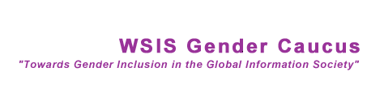

DEBATE ANNOUNCEMENT

Topic: ICTs and Human Rights (Women’s & Men’s)

The WSIS Gender Caucus will hold a debate on Tuesday November 15th in Tunis as part of its programme of activities for this second phase of WSIS.

This is our invitation to you to join in this activity in the following ways:
As a debater, judge or e-volunteer.

The debate will bring 6 intergenerational debaters from Africa, Latin America, the Caribbean, US & Canada, Europe, and Asia to debate how information and communication technologies have advanced or undermined gender equality. The debate will also suggest how sustained change in the service of gender equality might be achieved through the agency of ICTs in the future Information Society.

The WSIS Gender Caucus is seeking your help to identify the best debaters, judges and e-volunteers.

We need to find 6 debaters, one each (the best) from;

Africa, Latin America, the Caribbean, US and Canada, Europe, and Asia/Pacific

4 judges and 30 e-volunteers

The E-volunteers will help the debaters to put the debate together so the debaters will have help from around the world with the help of the e-volunteers.

Whether you choose to join the activity or not please make a nomination.
Using the short form below to make your nomination, please send your nominations to: Susana Fernandes< sfernandez@genderwsis.org> OR Florence Etta <fetta@idrc.or.ke>
= = = = = = = = = = = =
Name & Sex of nominee:
Country or Region of nominee:
Task for Nominee: Debater/Judge/E-volunteer
Age of Nominee in decades 20’s 30’s etc: (Required to balance debaters’ age)
Contact for Nominee: (Email address preferred)

