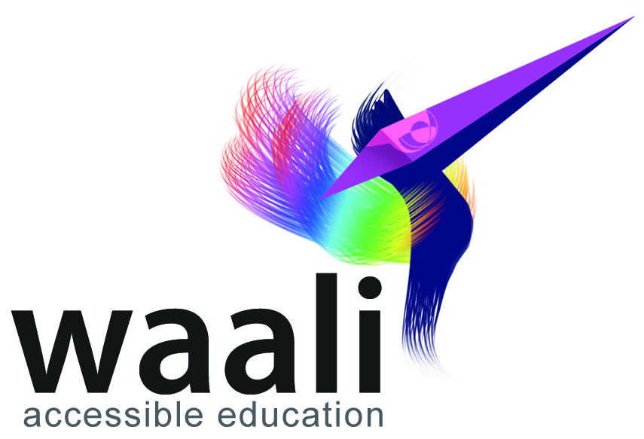
Country Manager – Kenya

Voluntary Position – Kenya, Africa

Apply by: January 14th 2014

• Flagship crowdsourcing platform
• Support a global initiative
• Start-up role where you lead the way

Waali International is a P2P crowdsourcing platform for merit-based education throughout the world. We are setting up local chapters throughout Africa, for which we are seeking a Country Director. This is an exciting new opportunity and we are looking for a person that will come with proven leadership ability and recognized knowledge of education. The role as the Country Director will be an amazing opportunity for someone who is passionate about education for all and ready for a creative new challenge.
About the role:

We are seeking a dynamic and self-driven individual who has a significant level of experience leading complex educational and/or projects in the IT/web sector.

The Country Manager will develop and lead the Waali’s country strategy in Kenya. In this key leadership position you will be responsible for establishing and managing complex portfolio initiatives and handling all areas of operational startup in your country and team while working with partners and stakeholders to strategically design, plan and implement a regional educational crowdsourcing initiative.

The primary focus of this role is to establish and develop an effective Waali presence in Kenya which has a recognized public profile and advocacy and fund-raising strategies. The Director will be integral in shaping the organization’s substantive educational change agenda, both in Kenya, and globally, through Waali’s influence. Building strong relations with the educational sector and strengthening the public constituency of support for education are key expectations from this role.

To be successful in this position you will have solid work experience in Kenya and the capacity to engage and influence senior levels of government, multi-lateral agencies and other relevant stakeholders to build strategic advocacy.
Previous experience at Country Manager or Director level is an advantage, as is exposure to globally operating virtual teams. Fluency in written and spoken English is essential.

Job Duties:

- Establishing and managing complex portfolio initiatives and handling all areas of operational startup in your country and team while working with partners and stakeholders to strategically design, plan and implement a regional educational crowdsourcing initiative.
- Establishing and developing an effective Waali presence in Kenya that has a recognized public profile and advocacy and fund-raising strategies.
- Shaping the organization’s substantive educational change agenda, both in Kenya, and globally, through Waali’s influence.
- Building strong relations with the educational sector of Kenya and strengthening the public constituency of support for education are key expectations from this role.

Skills/Qualifications:

- A deep understanding of national and sub national political realities and demonstrated innovative solutions to educational challenges, particularly in relation to women and marginalized groups such as indigenous peoples.
- Extensive experience of working in relevant fields at a senior level, including leading a known and respected national or international organization.
- A recognized national public profile, known to be non-partisan and with the highest credibility and integrity.
- A proven track record of personal leadership, influence and impact, working with teams closely and remotely.
- Bilingual (English + local language).

How to Apply:

Please send your CV and a letter of motivation to you@waali.org. Additional references will be welcome.

Contact Us:

Waali e.V. Waali International
Partnachstr. 2 Cocody Les Deux-Plateaux
81373 München 27 BP 301 - Abidjan 27
Germany Côte d’Ivoire
www.waali.org www.waali.org
info@waali.org info@waali.org

