 | United Nations Educational, Scientific and Cultural Organization  Organisation des Nations Unies pour l’éducation, la science et la culture
Office of the Communication Adviser for Eastern Africa
Ref: RCA/NAI/KENYA/05/ Nairobi, 20th April 2005

Dear Sir/Madam,

Subject: Information and Communication Policy and Framework project

Multi sectoral Consultative meeting 27-28 April, 2005 Safari Park Hotel, Nairobi

Following the successful launch of the project Kenya, National Communication and Information Policy Framework UNESCO is pleased to invite you to a stakeholders’ meeting, to be organized at the Safari Park Hotel on the above dates in partnership with the UNDP and Government of Kenya.

The overall aim of the workshop is to prepare an agenda which will include views from all partners in the Communication and Information Sector to be presented at the National Consultative Meeting which will be organised by the Government of Kenya in May. The agenda of the meeting will deal with all the different initiatives promoted by the government such as the E-government project as well as the ICT Policy.

All sectors interested (i.e. the Government, the Private Sector, Civil Society, the Public and private media as well as media professional associations and training institutions) are invited and hopefully will be attending this meeting which will aim at establishing the roadmap for an overarching framework for all initiatives in the Communication and Information sphere. The main reference documents for these debates will be the ICT Policy document, the Draft right to information bill and the e-government strategy. In addition, the Poverty Reduction Strategy Programme (PRSP), Economic Recovery Strategy Programme (ERSP) and the Millennium Development Goals (MDGS), adopted by the government, will provide background to the discussions.

This initiative aims to enhance the capacity of the national information and communication sector to contribute to introduce accountability, transparency and democracy at all levels of the State through professional excellence in the collection, management and dissemination of information for poverty reduction and sustainable development.

The proposed meeting is therefore designed to discuss, sectoral information and communication needs as well as the diverse aspects pertaining to the State - Citizen interaction and the overall information flow of information within government.

Attached I have pleasure in sending you the draft agenda as well as a copy of the project concept paper for your information.

Kindly confirm your participation with Ms. Agneta Radol on Tel. 622347/348/616, or Mr. Martin Ocholi by email : martin.ocholi@unesco.unon.org

Sincerely yours,
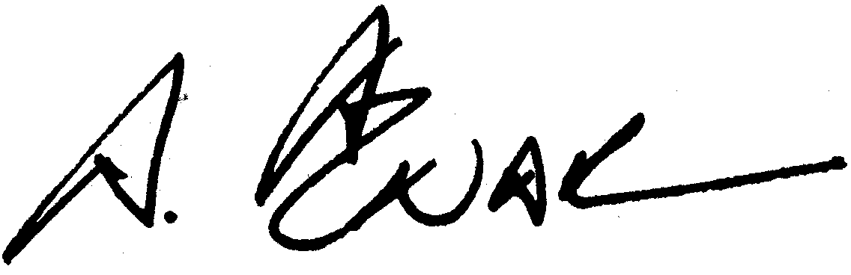
Alonso Aznar
UNESCO
Regional Adviser for Communication and Information for Eastern Africa

