

Catalyzing national ICT policy development in Kenya;
Lessons to position for the future

Presented by

Summit Strategies Ltd
ICT Research & Consultancy

Chania Avenue Kilimani
Mail: P.O Box 62454 - 00200 Nairobi Kenya. Voice: +254 (20) 3875824 /(0) 722520090
Contact E-mail address: mureithi@summitstrategies.co.ke
Table of contents
1 Background: 1
1.1 Project Objectives: 1
1.2 Research questions 1
1.3 Importance of the study 1
1.4 Scope of the study 2
2 Contextualising ICT development dynamic in Kenya 3
2.1 Context of the study 3
2.2 Glimpses for the literature 4
2.3 Socio political dynamics influencing ICT development 5
2.3.1 Theory of policy development and relative positioning 5
2.3.2 ICT policy evolution 7
2.3.3 Drivers for ICT policy 10
2.4 Role of networks in relation to performance of Kictanet 12
2.4.1 Multistakeholder partnership and networks in ICT 12
2.4.2 Characteristics of networks 14
2.5 Impact of MSP processes 14
2.5.1 Structure and style 14
2.5.2 KICTAnet foundations 15
2.6 Strategy and strategic options 16
2.6.1 Space for Kictanet future 16
2.7 Key issues for research 17
3 Project Activities/Methodology 18
1 Questionnaire 19
1.1 References 22
1.2 KICTAnet 23

Acronyms

Operational definitions

Multistakeholder
multistakeholder is a broad term to describe grouping of governmental, intergovernmental, civil society and private sector stakeholders to bring about change. These changes includes;

- sharing information on problems and solutions
- developing guidelines for best practice for policy making, commercial activities and reporting etc
- developing and delivering action plans for implementation
Calder (nd)

Networks Ownership

'a phenomenon where the members work within the network and not for it , not simply performing the business of the network but taking responsibility for the ensuring that the business remain important , beneficial and well implemented'

Bernard (98)

Background:
This study reviews the evolving ICT policy and regulatory environment in Kenya and the gaps that emanate from the changing dynamics and explores where KICTAnet contributes or can contribute to its development .The study further explores the internal dynamics of KICTAnet and how the key drivers of the organisation influence Kictanet to ensure success towards its mission. The study output is expected to contribute towards defining how KICTAnet can position itself to contribute to effective change to serve the nation and the ICT consumer.

Project Objectives:
The general objective is to take stock of the last two years of KICTAnet existence and explore a strategic positioning to ensure a relevance for KICTAnet and proactive contribution in ICT development in Kenya . To achieve this general objective the study has the following specific objectives, to;
- Investigate the socio-political dynamics influencing ICT development and the prevailing situation that pointed to the necessity of creation of KICTAnet and document previous efforts to establish multi-stakeholder partnerships (MSP) forums and challenges faced.
- Describe KICTAnet and its internal operational dynamics to manage differing membership expectations
- Assess the impact of kictanet and lessons on ICT policy evolution
- Propose a strategic future role and positioning to catalyze ICT policy development

Research questions
What is the optimal strategic positioning of Kictanet considering;
- the socio dynamic drivers that influence ICT policy change and how should MSP efforts respond to this change
- kictanet and its internal dynamics
- the impact
- the optimal strategic position to catalyse change

Importance of the study
In seeking to address the fast changing dynamics affecting ICT policy development and how to catalyse its growth in the long term ,the study attempts to define strategic options that KICTAnet can pursue and an entry point to steward the ICT policy evolution in Kenya . Consequently, the study would be of interest to a number of stakeholders in ICT sector described in the following paragraphs.

Kenya government and its organs will have clarity on a professional body that they can deal with . The current National ICT Policy guideline gazetted in March 2006 stresses the role of the civil society organisations and professional organisations. The government recognises the necessity of the these institutions among others playing their respective but interdependent roles to promote ICT growth . In the ICT Policy the government recognises the role of the civil society –‘ to inform the policy making process by making relevant contributions in regard to ICT access, e-education, poverty reduction and e-Governance.’ Similarly, the policy recognises a need for strong professional bodies ‘.. to foster professional ethics, standards and human resource development.’ ( RoK 2006). KICTAnet seeks to contribute in that space and the study will explore how best it achieves these key objective to contribute to the government’s objective for ICT development .
CATIA countries and African countries generally can learn significant lessons on do’s and don’ts for an effective multi-stakeholder partnership. The emerging ICT technologies and consumer demands put immense pressure for change. It is imperative that the stakeholders develop vehicles to effectively manage change and lessons from the study would be useful in this regard.
KICTANET members will have a formal framework to share and modulate expectations for overall ICT market growth . The membership has very varied expectations and how to handle these expectations is a important for the growth of the growth of KICTAnet into the future
Finally and most importantly the leadership in KICTAnet will have a strategic framework to guide KICTAnet growth and contribution in the future .

Scope of the study
The scope of the study is KICTAnet operations within the Kenyan ICT policy and regulatory dynamic. The study will trace the policy and regulatory framework evolution and seek to develop a scenario over the next few years to position KICTAnet .

Contextualising ICT development dynamic in Kenya

Context of the study
The study takes into account the stakeholders, the processes and the environment of ICT development as illustrated in Fig 1. Stakeholders include the Ministry of Information and Communications (MoIC) driving policy, parliament as the custodian of the ICT law operators and finally consumers as key in the operations, provision and consumption of services. Under these key stakeholders there are others playing a key role as indicated in Fig 1. The processes include the realisation of a broad policy guideline to encapsulate the strategic intent at national level . This intent is to the realised by the legal framework and finally licensing to guide the market players

Each of the stakeholders operate in a distinct environment . In developing the ICT policy, MoIC seeks to create relevance of the sector to the rest the economy and therefore concerned about development issues while the regulatory framework operate at the industry level and concerned about the success of the industry in bringing about change, and finally the operators are concerned by an environment that enhances their performance as measured by effectiveness , efficiency and timeliness.

The study reviews the environment and a strategic positioning of the kictanet. should it be cross cutting across all stakeholders or should be an in-depth vertical to serve an niche? The paper will review the implications of both dimensions.

Figure 1: contextual illustration of Kictanet space
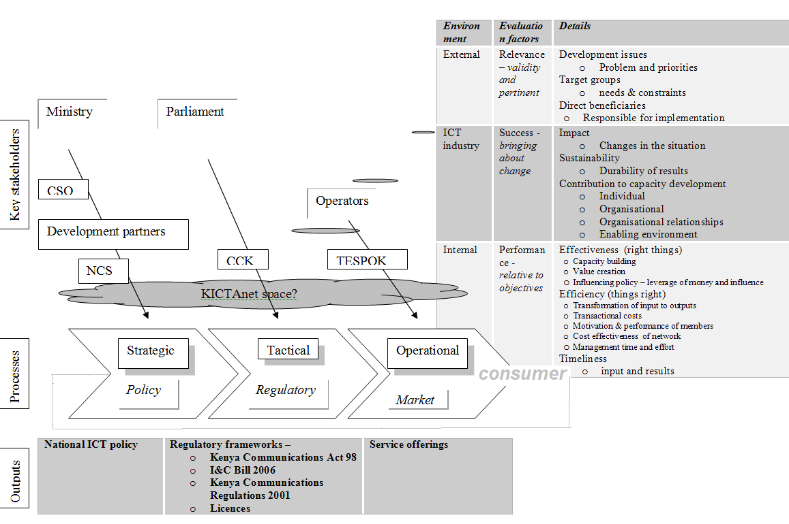
Source: Summit Strategies (2006)

Glimpses for the literature
The literature reviewed for the study illustrates past research work and body of knowledge and experiences on based on four broad dimensions namely,

- the evolution of ICT policy in Kenya and understanding of theoretical framework undergirding its evolution and the entry point for civil society
- internal operations of the MSP and lessons for KICTanet
- the impact of MSP processes and
- finally strategy concepts and strategic options

This information seeks to set a backdrop of the experiences that could help KICTAnet to understand the environment and managing the changing dynamics

Socio political dynamics influencing ICT development

Theory of policy development and relative positioning
According to Brock (1994) public policy creates public good by creating a predictable framework that results in production of goods and services. The premise that the policy framework is predictable and should not easily be changed once implemented is a logic that drove US telecommunications policy development
Developing countries like Kenya appear to be driven by the same desire. To develop a framework that captures the aspiration of the citizen condensed into a policy document . This would also be a promise and coalesce efforts to achieve certain goals. Conscious of the poor and unpredictable quality of services, the policy evolution is based around the recognition to create public good which is predictable. All other features around policy are tools to realise this objective
In doing so, Kenya opted for a tied framework with the policy instrument driving legal and regulatory aspects. This is illustrated in fig 2

Figure 2: Tiered approach to sector management
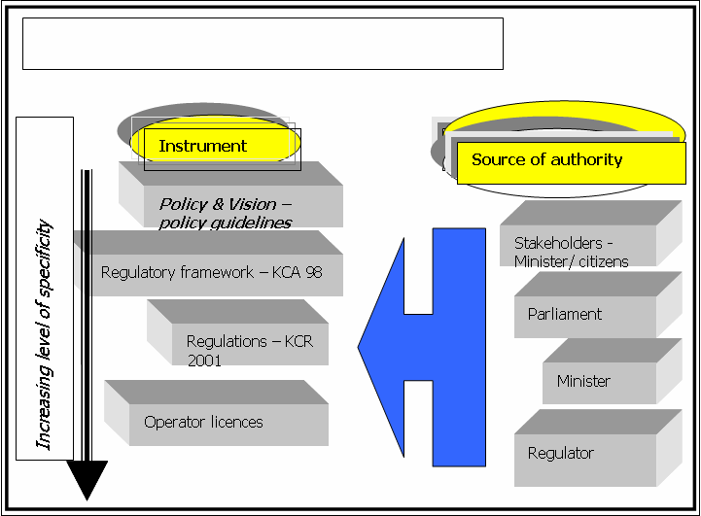
Source : Summit Strategies ltd (2006)
No theoretical framework was available to justify this tiered approach to the ICT sector management. However, the liberalisation process in Africa since 1995 have created similar structures and liberalised ICT environments are now characterised by a clear distinction between the ministry responsible for communications, a regulator and the operators each with a distinct role. Based on this framework, Kenya developed a institutional framework illustrated in Fig 3 established by the Kenya Communications Act 1998.

Figure 3: institutional positioning of policy
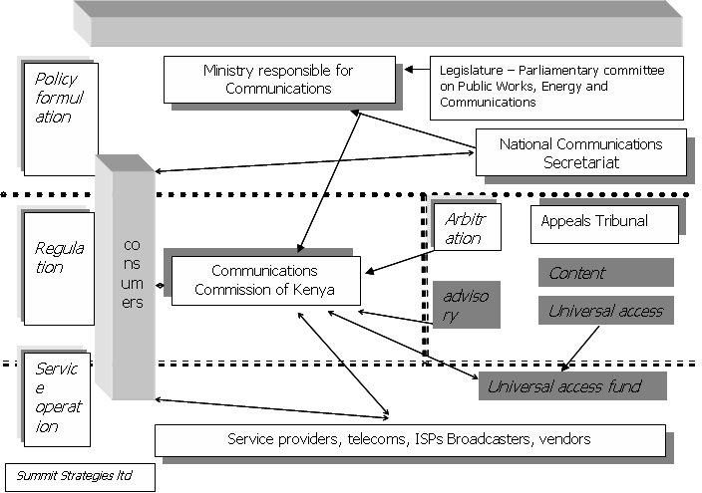

To assist the Minister to design policy, the Kenya Communications Act 1998 provides for the establishment of National Communications Secretariat (NCS).
Other institutions that can influence telecommunications policy and regulation are set out in figure and include;
- The Parliamentary oversight through the Parliamentary Committee on Energy, Communications and Public Works. Aside from the Act, Parliament has not influenced ICT policy lately.
- In making ICT regulations, the minister has a duty to consult CCK. This allows CCK to contribute in regulation formulation indirectly.
- Monopolies and Prices Commission (MPC) Act allow the Commissioner to determine matters that may affect competition in the economy including companies in telecommunications business. In the liberalised segment in the Internet provision, MPC has had a role to ensure competition and control mergers. In 1999, MPC cleared the take-over of an ISP (Net 2000) by another ISP (Africa Online) concurring that the resulting merger did not affect market concentration of Internet business.
- Kenya Communications Act 98 establishes sector specific dispute resolution mechanism in the implementation of the Act. Any dispute in the application of the Act by CCK is referred to the Appeals Tribunal. The decision of the Appeals Tribunal can be appealed in the Court of Appeal. The Tribunal jurisdiction is limited to the interpretation of the spirit of the Kenya Communications Act. By 2003, the Tribunal had delivered a judgement on interconnection rates dispute between the then Kencell Communications ltd a cellular operator and Telkom Kenya ltd among others disputes
The shaded boxes namely, Content and Universal Access Advisory Boards as well as Universal Access Fund are proposed by the Kenya Information & Communications Bill 2006 .

ICT policy evolution
The government has implemented ICT policy reforms between 1999 and 2006 which resulted in a number of structural changes in the ICT sector. The policy documents released in January 1997, April 1999, and Dec 2001 illustrated in Table 1 resulted in the following key structural changes;
- Elucidation of a long term vision of the ICT sector to contribute to socio -economic development
- Redefinition and clarification of roles in telecommunication sector development. The policy identified distinct roles for policymaking, market regulation in a competitive environment, dispute resolution and operation of services among multiple players. Private sector would henceforth be the key investor in the sector with profit being a key incentive.
- Promulgation of a new market structure driven by the private sector in a competitive environment. Government was to withdraw as an investor through privatisation of the incumbent telecommunications sector provider.
In the operation of services, multiple operators compete in various market segments based on a philosophy of private sector operation in a competitive environment. The government consider competition as a tool to safeguard consumer interest by forcing lower tariffs and improved quality of service.
It is clear that not all objectives were realised . As illustrated in Table 1, some of the efforts to deepen the liberalisation were not achieved . Additionally, these policies were inadequate in key areas and did not especially address convergence in ICT but instead focused on telecommunications only . This has resulted in the clamour to review the Dec 2001 policy

Table 1: key stages in evolution of ICT policy
Timeline | January 1997 | April 1999 | Dec 2001
Policy evolution
Tool | Postal & Telecommunications Sector Policy Statement | Telecommunications & Postal Sector Policy Statement | Telecommunications & Postal Sector Policy Guidelines
Objective | Improve access to telephony services
Strategies | - Restructure incumbent operator – Kenya Posts and Telecom Corporation to separate roles  - Privatise the incumbent telecommunications operator – Telkom Kenya Ltd  - Establish of new regulatory framework  - Introduce competition in a defined market structure  - Provide for universal service to cater for those disadvantaged by commercial market forces  - Enforce foreign equity restrictions to 30%  Policy established of a policy advisory secretariat to advise on necessary policy changes | In addition to strategies of January 1997 ,  - Reversed foreign equity participation to a maximum of 60%  - Determined that 26% equity stake of Telkom Kenya ltd to be sold to a strategic investor  Clarified  - role of the regulator  - role of policy advisory secretariat  - the market structure – provided for a five year exclusivity to incumbent on voice market  Recognised the provision of internet backbone | Gazetted the April 1999 policy statement to conform with the requirement of the Kenya Communications Act 1998  Other policy actions defined in the strategy were:  - Exempt government agencies from frequency licensing fees and licensing conditions  - Reverse foreign equity participation to maximum of 70%  - Reverse equity to be sold strategic investor to that 49% in privatisation
Stakeholder involvement | Government only
Regulatory evolution
Legislation | Enactment of Kenya Communications Act 1988  Provided for establishment of;  - Regulator – Communications Commission of Kenya  - Policy advisory secretariat _ national Communications Secretariat  - Dispute resolution mechanism - Appeals Tribunal  Defined mechanism to manage the sector |  | Kenya Telecommunications Regulations 2001  Provided for operational guidelines on;  - Fair competition  - Operator Licensing  - Frequency licensing  - Interconnection  - Type approval of equipment  - Numbering  - Tariff regulation  - Operator reporting
Regulation |  | Licences issued in line with market structure defined the Policy guidelines. Enforced monopoly for five years in fixed line services | Failed privatisation of incumbent operator  Failed licensing process for  - Commercial trunked radio licences (2)  - Regional telecommunications operator licences (7)  Failed licensing process for  - Second network operator  - 3rd cellular mobile operator
Operational consequences
Market competition |  | Monopoly in fixed line , and international services for five years  Duopoly cellular operators  Multiple players in internet service providers
Growth and expansion indicators | Fixed line penetration – 1%  Mobile penetration – 0.01%  Internet usage –negligible |  | Fixed line penetration – 0.7%  Mobile penetration - 12%  Internet usage penetration 4.5%
Affordability | Internet dial-up from USD 185 per month  Mobile – total entry costs approx US$3850 |  | Internet dial-up US$13 per month  Mobile - total entry costs approximately US$40  Fixed local – increase in local calls , decrease in other national and international call tariffs
Consequential new investments flows
Successful |  | - Cellular licence USD 110M (2)  - Regional Telecommunications Operator US$0.5M (1)  - Internet and data operators licensing (multiple ) | - Cellular infrastructure investment estimated at US$ 600 M  - Committed investment by regional telecommunications operator of US$20 000 over first 3 years of operation  - Significant infrastructure investment
unsuccessful |  | - Privatisation of incumbent operator licence US$ 350M and additional US$ 500Million investment over four years on offer  - Seven Regional Telecommunications Operator licences pledged at US$ 38 M and US$326 million in infrastructure investment over first three years of operation  - Commercial Trunked Radio Operator licences -  - Second National Operator  - 3rd cellular operator – licence fee US$27M and US$75M immediate infrastructure investment on offer
Source: Summit Strategies from respective policy statements

The intention of the policy was to position ICT as a service to the economy. Despite early attempts by the government to review the sector policy to widen its scope and integrate the policy with socio-economic endeavours, this was not to be until 2006. This slow pace of ICT policy development had encouraged other sectors to produce sectoral strategies with a consequential loss of synergy. Incidentally, the first one was the government itself releasing an e-government strategy in 2003. The same year however, the government initiated a policy review to address the policy weakness with a national ICT policy realised and gazetted in March 2006. The key focus is illustrated in fig 4

Figure 4: addressing changing paradigms
Timeline | Aug 2003 | June 2005 | March 2006
Policy evolution
Tool | ‘Draft’ National ICT infrastructure | Draft ‘ National ICT Policy ‘ – not finalised by government  National stakeholder consultation | National ICT Policy guideline approved by Cabinet and Gazetted
Objective | Exploit ICTs to improve the livelihoods of the Citizens and become a centre of excellence in the Region and Internationally
Key features |  | Convergence of services  Exploitation of ICT for national development  No monopoly
Stakeholder involvement | Controlled stakeholder involvement | Open to all stakeholders to contribute. Government proactively facilitated contribution by all stakeholders
Regulatory evolution
Regulation |  | New licensing framework published by CCK - technology neutral | Information & Communications Bill 2006 (Draft) published to repeal Kenya Communications Act 1998
Source: Summit strategies

Drivers for ICT policy
In a research carried out for Institute of Economic Affairs reported in Mureithi (2003), findings report disparate perspectives by key stakeholders on policy focus. The study conducted among 32 key government agencies , ICT private sector suppliers and civil society involved in ICTs sought to identify the factors and perspective on ICT policy development in the country .
When questioned about the issues that need to be addressed to support ICT development the study noted disparity of views. The civil society for example stated that the key issue to address in policy is the enabling environment while the private sector indicated that the critical component for ICT policy to address is the infrastructure . Both parties do not see content as major issue as indicated in Figure 5

Figure 5: critical policy component to address for ICT development
Source: Summit Strategies

Among the reasons advanced by the private sector for their choice was that infrastructure is the basic requirement for any meaningful implementation. Private sector also recognised a need for government to provide an enabling environment but this was secondary in ranking. Civil society on the other hand considered enabling environment as a key issue arguing that it would be much easier to address the challenges brought about by other constraints. Secondly, it would mean that dialogue amongst all stakeholders was open, and as such, cooperation was a prime consideration. Each stakeholder was therefore investing resources in areas it considered important at the expense of synergy.
Secondly, the two major stakeholders private sector and civil society organisations did not agree on the key applications to drive ICTs. The private sector was of the opinion that the key driver for ICT development was e-commerce while for civil society it was education as indicated in Figure 6
Figure 6: flagship applications to drive ICTs development
Source: Summit Strategies

According to the respondents from the private sector, e-commerce encourages transparency, lowers costs; reduce barriers to entry, fosters competition, innovation, better service delivery, data services, and accessibility. CSOs on the other hand indicated that wide access to education can be equated to universal access to information and therefore empower the population . This would result in increased wealth creation, use of telemedicine etc

The study further found E-governance as the most important application followed by agriculture and e-commerce for organisations responding as ICT users. They presumably saw government as a stumbling block and therefore will get the greatest benefits from an efficient government using e-government. A further question in the survey indicated that all the players including government agencies have invested and continue to invest resources to contribute in the development of an ICT policy framework

Based on this survey, it is clear that the key stakeholders - private sector, civil society and users - were pulling in different directions. These are the challenges driving various interest groups in the search of an overarching solution and KICTAnet entered the space with these dynamics

Role of networks in relation to performance of Kictanet
This section sets out a framework to review the role of networks as tool for change in development.

Multistakeholder partnership and networks in ICT
Multistakeholder partnerships and networks are now commonly used terms and often in usage cited interchangeably. However, literature cited in this paper suggests that networks is an essential tool for the multistakeholder partnership process.
According to Calder (nd) multistakeholder partnership is a broad term to describe grouping of governmental, intergovernmental, civil society and private sector stakeholders to bring about change. These changes includes;

- sharing information on problems and solutions
- developing guidelines for best practice for policy making, commercial activities and reporting etc
- developing and delivering action plans for implementation

Earlier literature define networks . In a review of a experiences of knowledge networks carried out on the International Development Research Centre (IDRC) supported networks, Bernard (1998) argues that 'networks are more or less effective on the basis of how well they accommodate the different motivations, needs and capacities of members, donors and participating organizations; and how well they respond to their environments in doing so'
The building blocks of the multistakeholder are networks which according to Tandon (1998) are distinct from other forms of organisations such as formal membership organisations and umbrella organisations. A key advantage of networks i.e. network advantage for information networks over individual or collaborative approaches to change are;
- emphasis on joint value creation by all members within the network
- strengthening the capacity of research and communications in all members
- Identification and implementation of strategies to engage decision makers more directly. Network members bring with them their own contacts and spheres of influence thereby extending their reach and influence of all partners Creech (2001)
Bernard (98) attempted to discover the factors associated with network success and failure and note as follows, that ;
- flexible internal management that allows the creation of solidarity around a shared purpose and allow members to work together on a common tasks. Where the only the tasks were the purpose of the network , such a network remains dependent on the outside initiator and become increasingly irrelevant to the national context
- learning through diversity by recognising that the members come from different backgrounds. While the diversity is advantageous it also spawns high level of turnover which may make it difficulty to strengthen network capacity.
- creating shared agreement through clear goals and limited focus
- managing change to be able to adapt over time in line with changing circumstances

A key theme for success is sense of ownership. Bernard (98) defines ownership as a
'a phenomenon where the members work within the network and not for it , not simply performing the business of the network but taking responsibility for the ensuring that the business remain important , beneficial and well implemented'
Finally, in their research Tandon (1998) identifies six core issues for effective networks, namely:
- Participation versus responsibility A balance between participation in, and responsibility for, the network must be promoted among its members. The more widely shared the responsibility for network direction, the more sustainable the network.
- Coordination versus control The purpose of coordination is to ensure the promotion of communication, not to control the activities of those who are part of the network. Those who associate with the network remain autonomous.
- Links between the person and the institution The key is to ensure that individuals are as active as institutions in networks. Institutional bases are critical for a network, but these institutions must respect the autonomy, informality, and space that the individuals in a network require to be able to effectively serve the mandates of the network.
- Information versus action There is an important distinction between solidarity and action. Although solidarity can be responded to by many members of the network, action requires the commitment of institutions to undertake follow-up programs.
- Focus versus inclusion Focus allows a network to influence public policy more coherently; inclusive networks disseminate ideas and experiences more widely.
- Process versus structure A certain amount of structure is necessary for continuity and accomplishment of purpose, but this structure must not curtail the evolution of the processes. (Tandon 1998)

Characteristics of networks
Networks can be categorised by types i.e. purpose, structure or function. According to Bernard (1998), the following are the defining characteristics of IDRC supported networks;
- are social arrangements much more than technical linkages of members who commit to one another for joint exchange to action and learning
- are forums for social exchange to allow members and users to interact, establish new relationships
- open new opportunities
- strengthen capacities among the individuals , institutions and within sectors
- sustain capacities by creating an enabling environment for sustaining potential for more focused research and development or by filling the gap of weak institutions
- enable creativity and risk taking by creating intellectual, emotional, and professional space for people and institutions to engage in new and uncertain activity without the need to commit too far'

Impact of MSP processes
Wilcox ( 2003)reports that some of the features of networks to realise the benefits are
- non-hierarchical with many links between members
- their activities focus on information and communications
- their structures are relatively light with a small core
- the main beneficiaries are likely to be members (Wilcox 2003)
To realise the benefits Tandon (98) in their research among civil society noted that the recurring purpose of people centred networks among the civil society which of interest to KICTAnet are to ;
- communicate among actors
- mobilise energy and resources as new ideas , designs and perspectives
- build linkages among actors
- influence public policy through shared analysis and vision

Structure and style
Bernand (98) explored a number of the structures that the enable the networks to function . Typical structures are lean comprising of the following key features
Membership comprise of the agenda setters and members at large. agenda setters in all networks there are a few dedicated team members who set the agenda. They carry the spirit of the network and have a strong attachment to the mission of the network. Outside this core team are the members at large . The members-at-large have a high propensity to enter the network and leave just as easily. Such members were not mission driven but function or task driven and once such need was realised the members left the network
Such a structure allow new members to enter easily and release those not getting value from the network .Selection of membership could be both individual and corporate

Figure 7: dynamism of membership of networks

Agenda setters
Sectoral interests e.g. ISPs
Members at large
Users

Communications strategy of the network established a communications strategy to the loop in all the members increasingly this is email based. Other tools for communications include informal and formal meetings/events
Membership expectations varied widely and the greatest challenge was to manage these interests

KICTAnet foundations and evolution
Kenya ICT Action Network ( KICTAnet)established in Oct 2004 has developed a niche the ICT sector and according to Munyua (2005) the founder and convener of Kictanet the following is a summary of the key milestones in the first years of Kictanet
- March 2004 organised a national ICT convention --?? ( kictanet was not formed)
- July 2004 a meeting convened in Nairobi by Association of Progressive Communications (APC) for national animators from Kenya, Nigeria, Mozambique and Ethiopia and conceptualises a framework to launch a multi-stakeholder partnership process (MSP) to address priority issues in ICTs. National level coordinators appointed in Oct 2004
- Oct 2004 establishment of KICTAnetnet - this is achieved through a series of workshop meetings. The meetings identified both the stakeholders and issues to be addressed by MSP process. Initial corporate members were APC/CATIA project, TESPOK, IDRC , KIF and Kenya WSIS Civil society caucus. the motivation for the formation was to 1) the common concern of the stalled ICT policy process and , 2) synergy for advocacy of common areas of interests
- November 2004 IDRC organise a visioning workshop and KICTAnet tasked to develop a desired state of the ICT landscape for ICTs in Kenya as well as sectoral roadmaps. Soon thereafter KICTAnet launched a 5 week email based process to comment on ICT draft policy published by the government . This was proceeded by training on the use of email facilitation . The final comments were presented to the government
- March 2005 organised a second national convention whose key theme was to evaluate progress on the national ICT policy process. KICTAnet was officially launched with many organisations making commitments to join
- April 2005 , convened a donor roundtable with the specific focus to ICTs and poverty reduction
The process provides some interesting lessons enumerated below
- ICT policy development was a dynamic process with broad and complex issues playing out concurrently
- diversity is a reality reflecting the different constituencies
- relationships are dynamic which grow and die over time
- parties cooperate, compete and co-evolve developing new capabilities and sometimes catalysing others

Strategy and strategic options
According to Calder (nd ) the benefits of multistakeholder model include; transparency and inclusivity, comprehensive analysis of issues, holistic planning through action of all members, sharing of skills and fostering innovation, leveraging financial resources, supporting leaders and encouraging laggards, developing trust and sense of ownership and commitment to take action.
The model also has shortcomings and one of them is that applicability is limited to where conditions of trust exist, the issue of legitimacy and especially whether civil society should be involved in policy development, lack of capacity to participate due to the divergent membership views, difficulties in measuring success ( Calder () )

Space for Kictanet future
Kenya ICT space is changing rapidly and changes and scenario planning provide tools for developing scenarios for the future and develop growth paths over the next few years. Scenario Planning is a methodology that allows practitioners to prepare for the future by looking at trends in the present and mapping how these interrelate with each other. From this study, a number of scenarios picturing possible future worlds are drafted, along with a description of how these futures could arise. Organisations then plan around these - with contingency plans for undesirable elements. Key change indicators are monitored and used to gauge how events are turning out. This approach is an attempt to bridge the “culture gap” between traditional planning that relies on single-point forecasting and scenario planning

Scenario planning tools are now standardised globally and are being used to develop long-term (5 to 50 years) scenarios in all sectors of human endeavours. These Future Sciences Research tools known variously as Scenario Planning, Foresight, and Futures Research are now helping to define this future.

This helps in future scenario of ICT development, space in the industry and positioning

Key gaps for research to address
The literature in this field illuminates some key challenges that need to be addressed
- Changing dynamic of ICT sector influenced by consumer taste – the legal framework follows the market. How can KICTAnet handhold and fast track the process as an intervention?
- What capacities does KICTAnet need to handhold on behalf of stakeholders?
- Can KICTAnet develop a mechanism using scenario planning tools to tap future trends and prepare be a frontier burster to and design a path for growth
- Can KICTAnet develop an enduring vision mission and over the long term and what structure within it can sustain this vision?

Methodology and design/ Project Activities

Research design
Exploratory and qualitative research to describe perceptions of stakeholders of the role and space of KICTAnet and the future positioning to continue being relevant and playing a role in catalysing ICTs

Target population
Population frame comprise of all ICT stakeholders at policy, regulatory and operational as well as consumers in Kenya as well partners with interest in Kenya ICT evolution

Sampling and sample size
Sampling is purposive to key informants familiar with some activities of Kictanet either at its meetings or through its mailing list. At least 50 such informants will be interviewed

Data collection tools
A tool to collect data has been developed and is attached .Additionally FGD will be conducted to collect data. The data collection will be administered through the questionnaire interview as well as internet mails

Data analysis
Once data is collected, the data will be checked for completeness, ready for analysis. The process included a cross check on the validity of data and content analysis to look for emergent patterns against data and linkages among parts of various data.

Questionnaire

Strategic issues for Kictanet

- To achieve its objectives, the activities of kictanet should be
Information exchange | meetings | projects | Learning | Sector analysis | Vision setting | Advocacy and lobbying

- What should these activities aim to achieve as a value proposition for the stakeholders
Social exchange among ICTs fraternity | New opportunities | Strengthen member capacities | Create enabling environment | Other specificy

- What are the generic focus that kictanet should continue focusing on
Policy | Regulatory/legal | Operational | consumer | Other

- What should be the breadth of issues?
External to ICT industry on the applications of broader consumers | ICT industry and relationships the market players | Internal and operational issues of the market players | Defined market segments eg ISP, broadcasting etc | Other  Specify

- In your opinion is kictanet current (on top of things) on the critical issues of the ICT sector
yes | no | Do not know

- How should kictanet asses the key issues to the satisfaction of its membership?
evaluation | Poll from members | Members prompt | Other suggest

- What should define the relations with key stakeholders
synergistic | partnership | subcontract | Loose association | Other

- In your opinion what is the timeframe of the issues that kictanet focuses on
Short term | Medium term | Long term | As need arise

Management of the kictanet

- What is the best form of membership to realise the objectives of the kictanet
individual | institutional | Other

- The target member should measure benefits by the following measure
Address critical issue at hand of the sector | Address mission of my organisation | Address mission of kictanet

- The preferred management structure to realise the mission is
Core team with loose members at large | Organic bureaucracy | Secretariat as clearing house | Other specify

- The preferred leadership style and relationship between the core team and members at large to realise the mission efficiently is best illustrated by the following statement
‘Try this ‘  Core team focus on capacity building | ‘Do as I do now’  Sets the pace | What do you think ?’  Listen to members | ‘members come first’  Seek harmony | ‘Come with me’ mobilise to a vision | ‘Do what I tell you’  coercion

- A binding decision is made by Kictanet when
Poll is taken to obtain majority view | Decision of core team carries | None against an intended a decision | Other

Assessing success and impact

- The best indicator for success of kictanet is measured by
Member endorsement | Participation at Kictanet events | Number of ideas/intervention Contributed | External recognition

References
Bernard A.K., (1998) IDRC Networks: an ethnographic perspective, Ottawa , International Development Research Centre
Brock , G.W., (1994) telecommunications policy for the information age- from monopoly to competition,, Cambridge Massachusetts, Harvard University Press
Calder, F., () The potential for using the multistakeholder network model to develop and deliver partnerships for implementation (.Type Two Outcomes.) for the World Summit on Sustainable Development, the royal institute of international affairs
Creech H (2001) measuring while you manage: planning, monitoring and evaluating knowledge networks Version 1.0 ,Winnipeg , Manitoba,. International Institute for Sustainable Development
Munyua, A., (2005) New Generation of Policy Development: The Case of Multi- stakeholder ICT Policy Process in Kenya, APC/CATIA Nairobi
Tandon R (1998)Networks as Mechanisms of Communications and Influence in Bernand viewed at http://www.idrc.ca/en/ev-26858-201-1- DO_TOPIC.html#tandon
Wilcox, D., (2003) a short guide to network development available at http://www.makingthenetwork.org/nets/

KICTAnet
The Kenya ICT Action Network (KICTAnet) was created in October 2004 and currently comprises over 50 organisations and networks of ICT initiatives in the country. It is a multi-stakeholder network with members from the private sector, civil society, media, academia, development partners and government. It is a network of committed volunteers from organisations, networks and groups, who believe in collaborative policy advocacy activities and the sharing of resources and skills. The advocacy activities are focused on the development and use of ICT to support poverty reduction and the transformation of livelihoods. For the past year, KICTAnet has acted as a central meeting point and platform for collaboration and activity for various stakeholders (media, civil society, private sector, development partners and government) interested in greater and more affordable access to Internet and Communications Technologies (ICTs) and services in Kenya.

The multi-stakeholder model for advocacy and input in ICT policy has proven to be very effective. For the 2 years that the Network has been in operation, members have contributed time, provided in-kind and cash contributions as required implementing activities.

Objectives of the Kenya ICT Action network are:

- To improve the effectiveness of ICT policy advocacy work by expanding base for support of ICT initiatives, providing support for members actions and audience for members ideas
- Encourage engagement in mutually supportive activities for lasting change
- Facilitate effective dissemination channels regarding the ICT policy process to keep everyone updated on what is going on in the sector
- Provide access to varied and multiple resources/skills
- Pool limited resources for the common goal to achieve effects that single organisations cannot
- Form a nucleus for action and attract other networks
- Link organisations and networks working at the community level to those specialised and working in the broader political space

Since creation, kictanet quickly filled a gap that existed to a create platform that brought together key stakeholders in the industry in a slogan – lets talk though we may not agree- . Today the organisation is acknowledged by all and sundry in government and out of the government. The process did have risks but most importantly are the valuable lessons for KICTAnet and for others to learn . it will be a vantage point for the organisation to look back as well as inward on what it could have done differently and the likely outcomes. This will provide a framework to create strategies for future to ensure its continued relevance in the fast changing market

See for example Glenn, J. C. and Gordon, T.J., ( 2005) 2005 state of the Future, American Council for The United Nations University , Washington DC describing state of future index and technology scenarios and the Futures Research Methodology

