7-8 February, Lagos
Customer Service & Call Centre Training Course
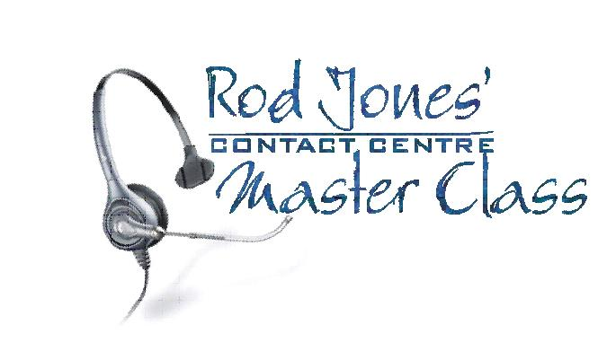
16-17 February, Nairobi
Corporate Network Management Forum: LANs, WANs, VPNs, Multimedia, VoIP, Security
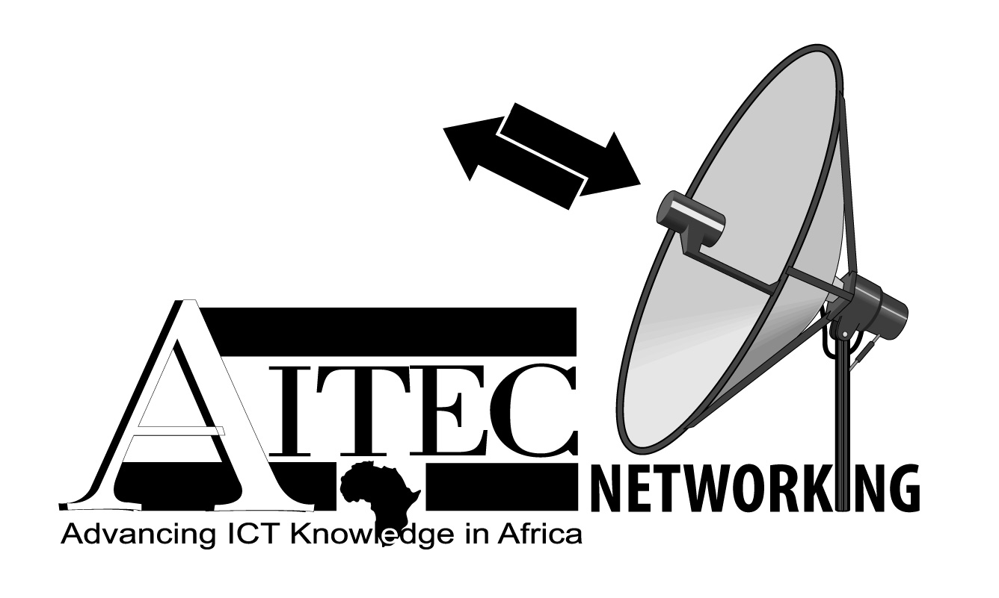

23-25 February, Nairobi
Idlelo2: Achieving Millennium Development Goals through Community Software (in association with FOSSFA)


2-3 March, Kigali
The second Rwanda National ICT Convention (Under the auspices of the Rwanda IT Authority)
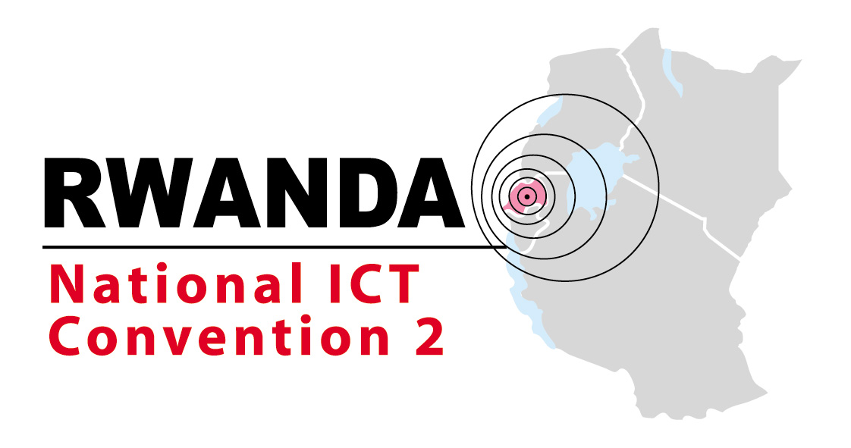

16-17 March, Nairobi
East African Banking & Financial Services & Markets

21-22 March, Lagos
Finance-IT Africa


23-24 March, Dar es Salaam
Tanzania GSM Forum

5-7 April, Nairobi
VSAT Installation Course (in association with Global VSAT Forum)


10-12 April, Johannesburg
The African WiMAX & CDMA Forum

26-27 April, Nairobi
Competitive Intelligence Africa


4-5 May, Maputo
The Mozambique National ICT Convention (Under the auspices of the Ministry of Science & Technology)

17 May, Nairobi
The AITEC African ICT Excellence & Achievement Awards: East Africa

18-20 May, Nairobi
The African Open Access Forum

24-26 May, Ottawa
The Canada-Africa Trade & Investment Exhibition & Conference

1-2 June, Nairobi
East African BPO & Call Centre Conference

14-16 June, Lusaka
AITEC Zambia

15-17 June, Nairobi
Telecom East Africa (in association with ECO Kenya)

20 June, Johannesburg
The AITEC African ICT Excellence & Achievement Awards: Southern Africa

29-30 June, London (Holiday Inn Regent’s Park)
AITEC Europe 2: The African ICT Investment & Partnership Forum


5-6 July, Lagos
The African VoIP Forum 3
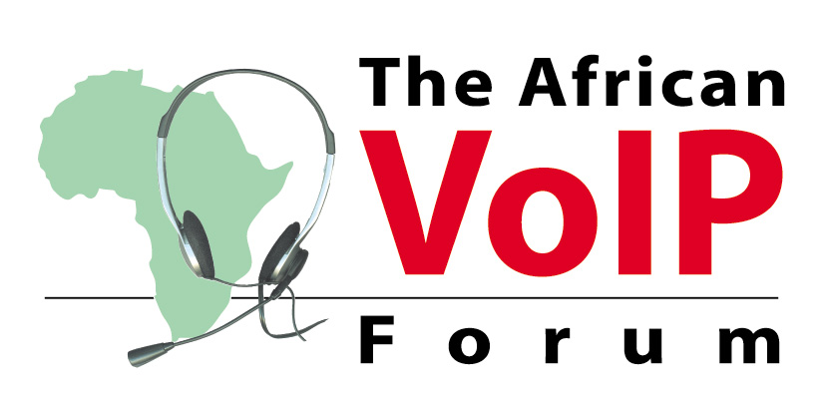

6 July, Lagos
The AITEC African ICT Excellence & Achievement Awards: West Africa

20-21 July, Dar es Salaam
Tanzania Banking Technology Expo & Conference

3-5 August, Mauritius
AITEC Indian Ocean
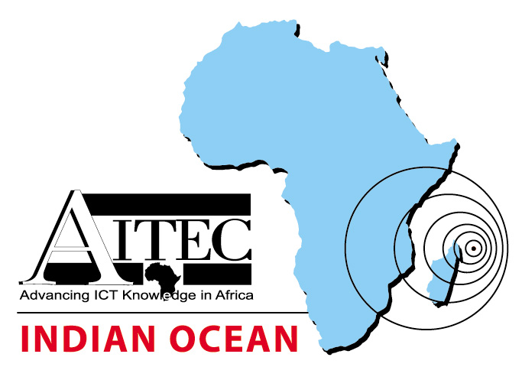

4-7 September, South Africa
ACT 8: The African Computing & Telecommunications Summit

30 August, Durban
The AITEC African ICT Excellence & Achievement Awards: Pan-Africa

16-18 November, Nairobi
Made in India Exhibition

23-24 November, Dar es Salaam
East African Government Technology Conference

To book exhibition space, contact:

Dorothy Fleming, dorothy@aitecafrica.com
Tel: +44(0)1480-495595 Fax: +44-1480-495596

In Southern Africa:
Zelda Axsel, zelda@aitecafrica.com
Tel: +27(0)72-326-3240

Full details:
www.aitecafrica.com

