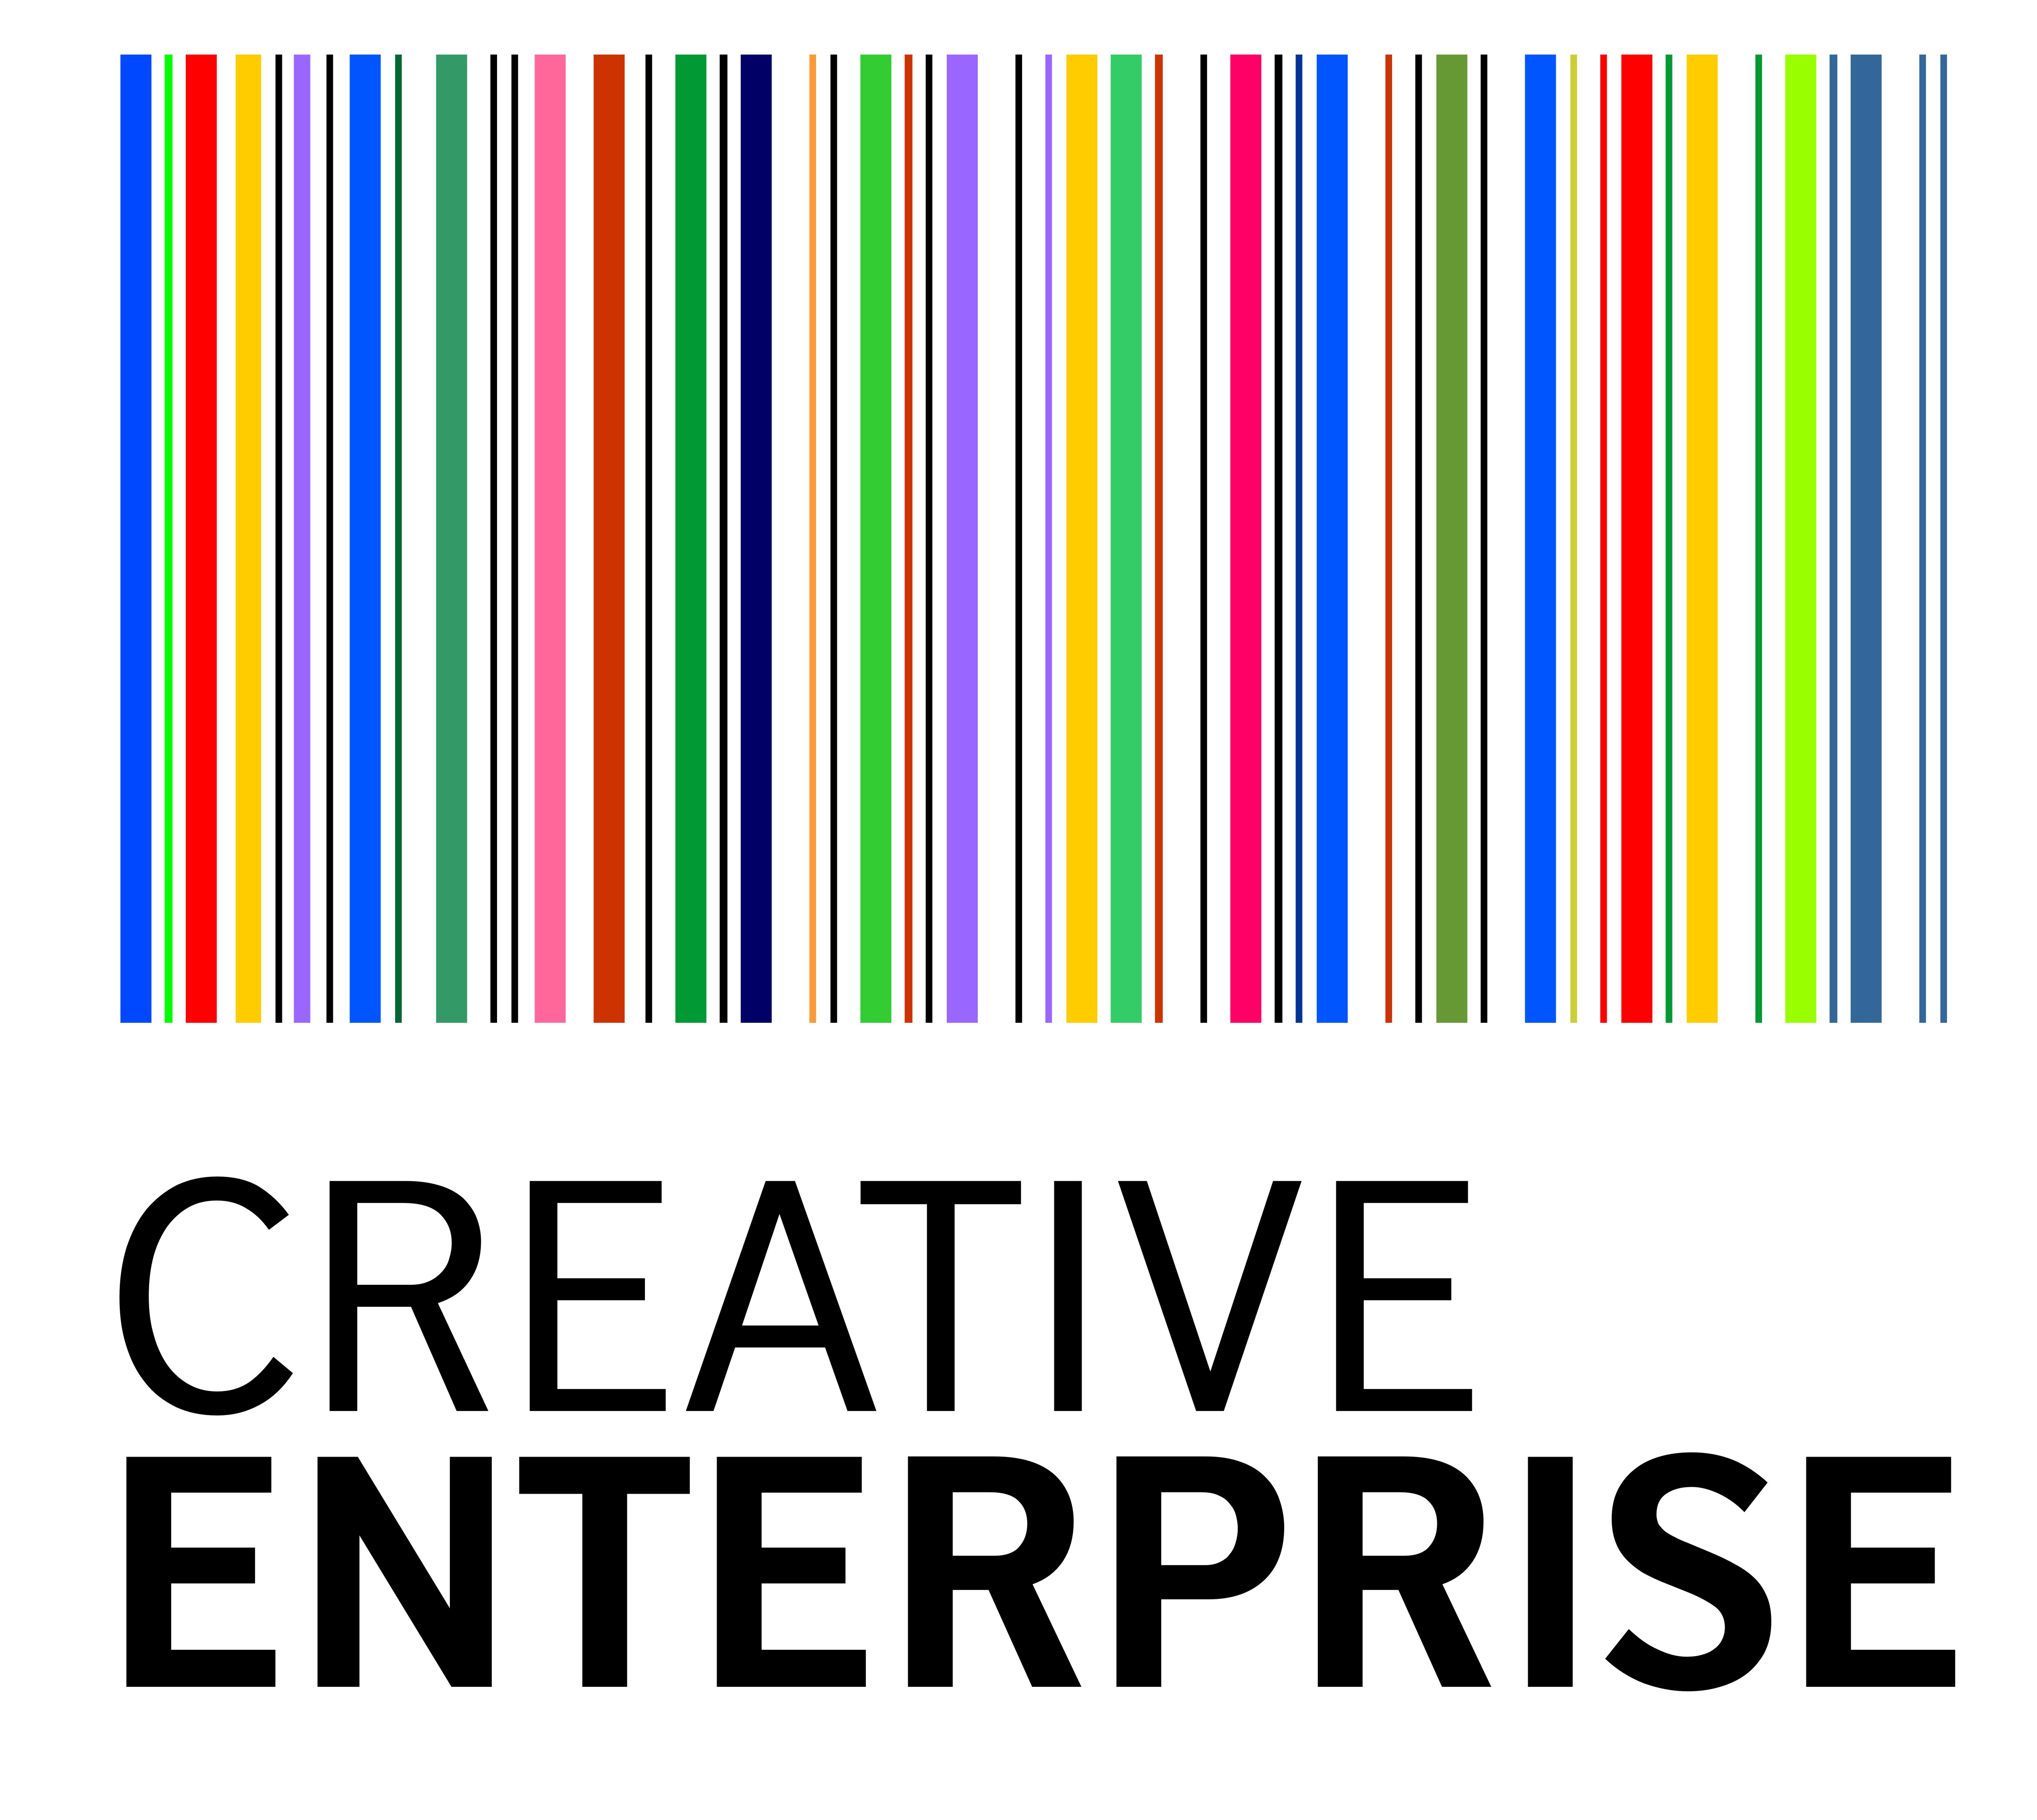

CREATIVE ENTERPRISE PROJECT BRIEF

Creative Enterprise is a project of training, mentoring, networking and secondments across the Creative Industries, led by the British Council. The project’s vision is to be Africa's most respected and effective scheme for developing aspiring creative entrepreneurs.

The creative industries are one of the UK's success stories. They generate around 7.5% of the country’s Gross Value Added, employ close to 2 million people and are growing at over double the rate of the wider UK economy. The Creative Enterprise programme will:

- Share the experience and expertise of the creative industries in their respective countries and the UK with young people across the participating countries in Sub Saharan Africa.
- Offer the best African creative entrepreneurs an opportunity to find pathways into the developed world markets, with the UK as their principal partner.

We want to affect the lives of many young entrepreneurs and aspiring entrepreneurs for the better, and take the most creative and most able on a journey that will radically improve not only their own life prospects, but their ability to act as forces of positive change within their own countries.

The benefits that the participants will derive vary from being given the first steps in training to fill the skills-gaps that can hold them back, to having increased access to culture and cultural skills (derived through the implementation of new practices, learning and enhanced networks), to opening up opportunities to more effectively or lucratively exploit their creativity.

The Creative Enterprise project will run in three phases:

Phase 1: THE CORE PROGRAMME covering generic business skills training. This will be an eight-module training course which is offered in conjunction with the leading business school in East Africa, Strathmore University.

Phase 2: THE ROUTE PROGRAMME covering business skills specific to various sectors.

Phase 3: REAL LIFE MENTORING involving participants being paired up with mentors and taken through real life situations to help them build up their creative businesses.

Graduation from one phase to the next will depend upon successful completion of the previous phase.

To participate you must already be a practitioner in any of the following sectors:

QUALIFICATION CRITERIA

- Already work in any capacity in any of the below named sectors
- Advertising
- Architecture
- Art and Antique markets
- Broadcasting
- Crafts
- Design (Including Fashion)
- Film, Video and Photography
- Software, computer games and electronic publishing
- Music & the Visual and Performing Arts (incl. Theatre)
- Publishing

- Be entrepreneurial
- Have a passion for your sector
- Have evidence of leadership capabilities in your sector
- Have evidence of originality of ideas

PARTICIPATION FEE

The cost of the CORE course is Kshs 5,000 per participant. Participants will be expected to have made full payment to the British Council before the commencement date of Friday March 12th, 2010.

The British Council is committed to equal opportunity and diversity. We encourage applications from candidates fully reflecting the diversity of the society in which we operate. We guarantee an interview to candidates with disabilities provided they fulfil the minimum selection criteria.

COURSE STRUCTURE

Module 1: So you’re an entrepreneur
Here we introduce participants to the theme of entrepreneurship. We introduce the idea that one can make a living out of creative hobbies, defining entrepreneurship as turning talent and passion into marketable products and services. We present some case studies (local / regional / international) of those that have been able to achieve competitive success in the creative industries and we discuss first in groups, then in the larger class. Each group will make a presentation to the larger class.

Module 2: Intellectual Capital / Contracting
This is about profiting from idea alongside protecting those ideas (and subsequent profit). The major problem with talent related venturing has to do with in-appropriate contracting but more importantly, copyright on intellectual property rights. This module will seek to expose participants to why and how they should protect their intellectual capital for future advantage and what they must watch out for in signing contracts.

Module 3: Brand Building / communicating your brand
What gives a brand value, and how can this value be realised? A few of our Kenyan talents have been able to create, manage and build brands in ways we have never seen before. In this module, we will show participants how to build their brand, how to position themselves and how to communicate this brand to their target audience.

Module 4: Negotiation and Networks
Negotiation is an integral part of any business venture but especially for those in creative industries. In this module, participants will be taught the rudiments of negotiation and how to achieve win-win outcomes. The importance of networks will be emphasized, and some guideline do’s and don’t established through cases. The module group is itself a network.

Module 5: Pricing and selling your product / services
This is perhaps the greatest challenge those in the creative industry face – how to appropriately price and sell their products and services. Unlike other products and services, creative industry players bring much more into the products and services being delivered. How can they price appropriately (especially for services) and convince their target clients that they are receiving value for the money being paid. What is the relationship between prices, sales and revenues. Some cases will illustrate how pricing can help brand development.

Module 6: Defining your market / Marketing yourself
The opportunities and challenges of markets. Every product or service is targeted at a specific market. In this module, participants will learn how to define their target market, and to position themselves as the “ultimate solution” for this market segment. Creating and exploiting new market opportunities through product development, and then protecting market advantage.

Module 7: Fundamentals of Business planning
Here we look at the concepts of opportunity recognition and value proposition. Local, regional and international examples. We also teach participants the rudiments of writing a simple but effective business plans and the tools available for writing such plans. Learning the language of business from a creative perspective. We will examine and discuss one or more business plan in the creative industry.

Module 8: Basic financial management / record keeping
Financial record keeping, together with the management of income and expenditure is critical to the survival of any business venture. Those in the creative industry are no exception. In this module, participants will learn how to keep transactional records in order to monitor progress and recognise money issues. How financial discipline is the key to business survival and growth.

© British Council/Strathmore University




Strathmore University
APPLICATION FORM
Please confine your answer for each question to a maximum of 200 words.
Name

Address
Best Telephone Contact
Best Email Contact
Educational Background
(Please list any post Secondary qualifications you have)

What Creative Sector do you work in or want to work in? Describe what you do or want to do.

What is your role within the Creative Sector? Employer/Business Owner, Manager/Employee/ Aspiring Entrepreneur

If an Employer/Business Owner, how long has your enterprise/company been in existence?

How many employees do you have (if applicable)?

What have you done about starting to work in the sector (if you are an aspiring entrepreneur?)

What do you expect to get out of this course?

PLEASE NOTE: To get the certificate at the end of the course and get a chance to move on to the next stage, 90% attendance is required.

All forms should be filled electronically and submitted on or before 5.00 p.m. on Tuesday 9th March 2010 to: jmatogo@strathmore.edu or Eva.Kiiru@britishcouncil.or.ke

