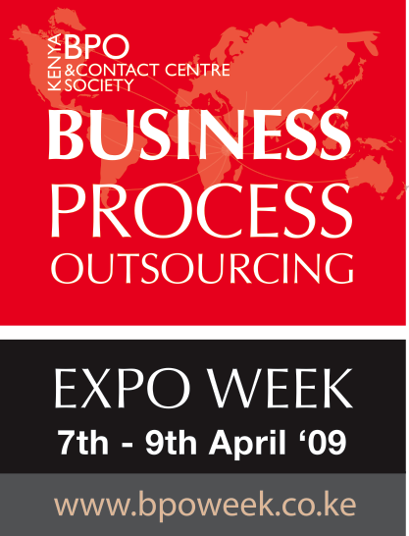 NATIONAL BPO EXPO WEEK
Exhibition Booking Form
(To book an Exhibition Space, please complete this form and Fax/Mail it to Kenya BPO & Contact Centre Society. Confirmation is based on First Come First Served Basis)

Participation Costs & Details
- Cost of a stand is Kshs 90,000 for members and Kshs. 153,000 for non members for a minimum lease space of 9m 2. This includes; a power socket, spot light, one table and two chairs for the Exhibitors per a 9m 2 stand. Additional accessories, if required, to be hired at the exhibitors cost. Costs inclusive of 16%VAT.

- Where funds are being transferred, transfer charges for effecting such a transaction will be loaded on top of the space costs. These will vary depending on the bank doing the transaction.

- A deposit of 50% is required to confirm the participation as an exhibitor by March 30th 2009. Cancellation of booking is only allowed within 14 days of booking otherwise 50% of the booking amount will be charged for the late cancellation.

Pledge:
We understand that our participation in the exhibition can only be guaranteed if we shall have fully paid all costs by 4th April, 2009. We hereby apply for a stand at the National BPO Week Expo at the KICC, Delegates Lounge on the 7th – 9th April 2009.

................................................................ M 2 space (local) @ Kshs. 10,000 per 2
......................................................... M 2 space (local) @ Kshs. 17,000 per 2

Exhibitor's Details:
Name of Organization/Firm:....................................................�
Nature of Business:....................................................................�
Type of Exhibits:..........................................................................�
Physical Address:.........................................................................�
P.O.Box.............................................................Town:.........................................Telephone:..................... Fax:..................................Email:......................................................................
Person signing the order Name:.............................................................................Title:....................................................................
Signature:.............................................. Date:.......................................Rubber stamp……………………….

Other Accessories
- Stand Décor – Kshs. 10,000 – Includes full décor to exhibitor stand in their Corporate Colour.
- Plasma Flat Screen – Kshs. 20,000 – Includes a 42 inch flat plasma screen.

For Bookings, contact

Joseph or Grace,
Kenya BPO & Contact Centre Society.
Studio House, along Argwings Kodhek road, 2nd floor
E-mail: secretariat@kenyabposociety.or.ke
Tel. No. /020-2391301/0720-873404 / 0722-663176/ 0733-917518

www.kenyabposociety.or.ke
www.bpoweek.co.ke
www.outsource2kenya.co.ke

