

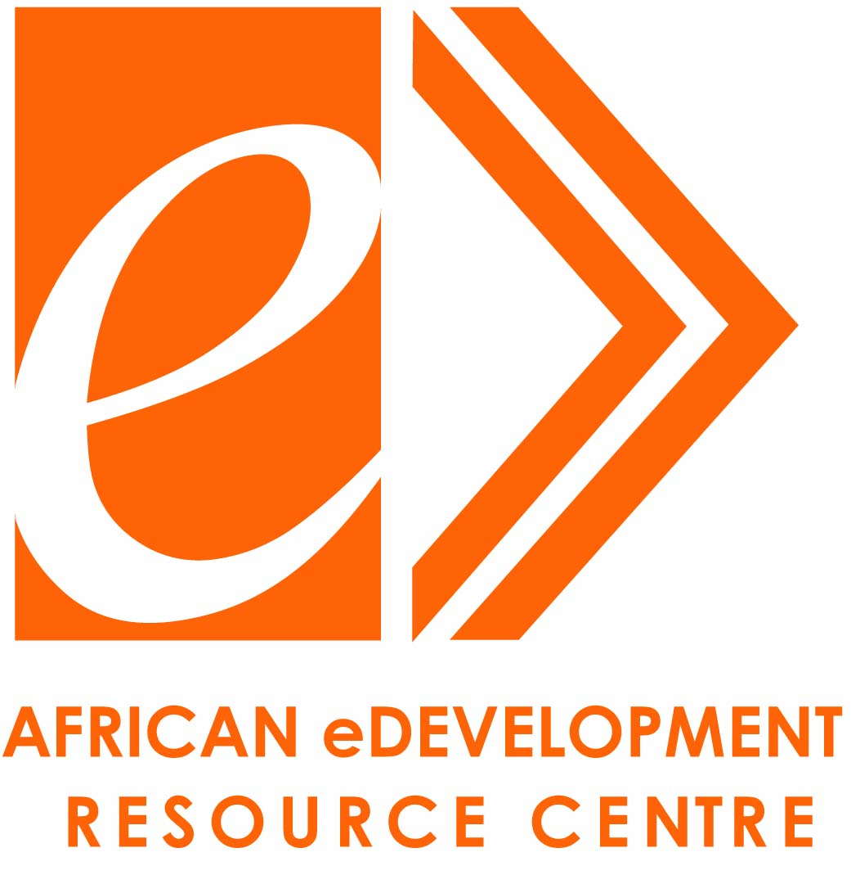

World Bank’s e-Development Thematic Group and partners

Present a Global Dialogue workshop on

Enabling Private Sector Delivery of Public Services:
Public Private Partnerships in e-Government Projects

Wednesday, June 25, 2008
9:00 am - 12:15 p.m. ET
World Bank Washington, D.C.
1850 I Street, Room I1-200, Videoconference & Live Webcast

Event Agenda

Time  (AM) | Duration  (Minutes) |  |  | Panelist | Subject Matter
Part 1: Opening Session
8:45 – 9:00 |  | 15 |  | Oleg Petrov, WB | Local sites introductions
9:00 - 9:07 |  | 7 |  | Samia Melhem, WB | Workshop Introduction
9:07 - 9:10 |  | 3 |  | Laura Samotshozo, USAID | Welcoming Remarks
9:10 - 9:20 |  | 10 |  | Sanjay Pradhan, WB | Opening Remarks
9:20 - 9:30 |  | 10 |  | R. Chandrashekhar | Keynote address
Part 2: Global Perspectives
9:30 – 9:40 |  | 10 |  | Andi Dervishi, IFC | WBG perspective
9:40 – 9:50 |  | 10 |  | Hrishikesh Potey, Evalueserve | Findings of Global Study  on eGov PPPs
10:00 –10:10 |  | 10 |  | Patricia de Baquero, WB | Procurement Aspects
9:50 – 10:00 |  | 10 |  | Dean Merrill, CGI | Case Studies in US and Canada
10:10 –10:15 |  | 5 |  | Donald Staples, VA TAX | Virginia Tax Case Study
10:20 –10:25 |  | 5 |  | Vivek Chaudhry, WB | infoDev eGov PPP Toolkit
10:25 - 10:55 |  | 30 |  | Samia Melhem, WB | Q&A
10:55-11:00 |  | 5 |  | Break
Part 3: Country Perspectives
11:00 -11:20 |  | 20 |  | Sam Somuah, GICTED  Emmanuel Darko,GCNET  Sam Mensah, MoFEP | Ghana
11:20-11:25 |  | 5 |  | Vahram Ghushchyan | Armenia
11:25-11:30 |  | 5 |  | R. Chandrashekhar | India
11:30 -11:40 |  | 10 |  | Yuri Hohlov, Anna Korobova | Russia
11:40 -11:45 |  | 5 |  | Victor Kyalo | Kenya
11:45 -11:50 |  | 5 |  | Wilson Muyenzi | Rwanda
Part 4: Closing Remarks
11:50 -12:10 |  |  | 20 | All sites | Key questions:  Which ideas did you find most powerful? What are the concrete next steps to take this agenda forward?
12:10 - 12:15 PM |  |  | 5 | Samia Melhem, WB | Key Messages of the Workshop and Closing Remarks

Note: The live webcast /e-discussion is at: http://www.worldbank.org/edevelopment/live, and slide handouts are downloadable from: http://go.worldbank.org/R8MULFAQQ0
Program Description
Using case studies, the speakers will draw out key lessons from PPPs in e-Government, discussing the challenges faced, solutions developed, as well as general recommendations for designing and implementing successful PPPs.
The key issues to be addressed (among others) are:
- Is private sector delivery in conflict with public interest? Are there any limits to outsourcing service delivery to the private sector?
- What are the most successful examples of PPPs in e-government? Is there a solid evidence of positive impact? Can these be easily replicated in other countries?
- What should governments do to ensure success of PPP approaches in e-Government?
- What kind of procurement system reforms may be necessary?
- What changes to legal framework may be necessary?
- Which business models have proven most successful to motivate both parties and produce best results?
The seminar participants include senior level government officials from a wide range of countries around the world, such as Russia, Armenia, India, Ghana, Rwanda, Zambia, Uganda, Kenya, Philippines, Samoa, Mongolia, Peru, Ecuador, Argentina, Tajikistan, Uzbekistan, Bulgaria, Barbados etc.
Previous eTG event on PPPs in e-Gov: http://go.worldbank.org/TNDD7BLDM0
To join our mailing list, please write to edevelopment@worldbank.org

