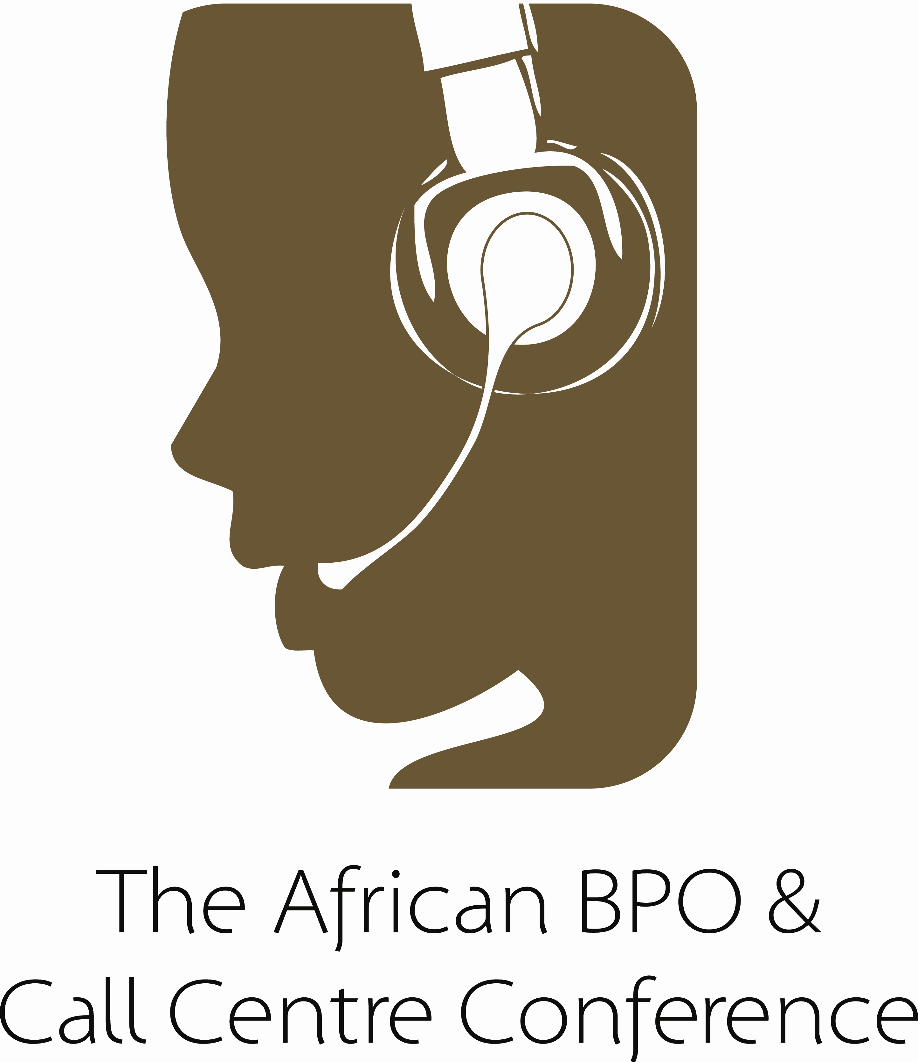
East Africa

Panari Hotel, Nairobi,

UNDER THE AUSPICES OF THE KENYA MINISTRY OF INFORMATION & COMMUNICATIONS


SUPPORTING ORGANISATIONS:


East African Call Centre Association

MAIN CONFERENCE
26-27 September 2006

WELCOME ADDRESS: Hon Mutahi Kagwe, Minister of Information & Communications, Kenya

KEYNOTE 1: Global service provision in a highly competitive world
Sesh Sukhdeo, CEO, KSA Global, UK

KEYNOTE 2: Start small – grow strong – then grow big
Rod Jones, Founding Partner, Rod Jones Strategic Solutions, South Africa

Leveraging global outsourcing as a basis for new venture creation in East Africa: Business opportunities & business models
Peres Were, Founder & Lead Consultant, Cascade Global, Kenya

The BPO space – defining front, middle and back office operations
Pauline Mwangi, MD, Strategic Link Enterprises

Developing Kenya’s outsourcing industry
Gilda Odera, Director, Skyweb-Evans, Kenya

BPO: Kenya vs Africa: A unified approach will serve us better than individualism
Wallace Gichoho, Secretary of the Kenya ICT Service Exporters (KISE) & Founding Director of Call Centre Africa Consulting, Kenya

Lessons from South Africa’s BPO experience
Mfanu Mfayela, CEO, South African Contact Centre Community

Lessons from Pakistan’s BPO experience
Kamal Faridi, CEO, Office Field, Pakistan

The challenges in setting up world-class call centre operations in Kenya
George Mugo, Head, Customer Service Department, Co-operative Bank, and Chairman, East African Call Centre Association

BPO in East Africa - Strengths and Challenges
Mugure Kabugua Mugo, CEO, E-Business Services, Kenya

SPECIAL TRAINING EVENTS AS PART OF THE CONFERENCE

21-22 September 2006
TRAINING COURSE
A two-day course presented by Rod Jones, South Africa
World Class Call Centres: The Strategic Issues (see www.aitecafrica.com for details)


If your organization needs to dramatically improve service delivery; to improve customer satisfaction; to constructively manage customer relations; to upgrade or to build a new call centre or contact centre – then this course is a MUST! Over two hundred delegates from companies, organizations and government bodies from all over Africa have already attended this powerful training programme and many are already deriving significant benefit. Rod Jones’ management development courses have been run in Kenya, Uganda, Tanzania, Botswana and South Africa.

Book NOW as participation will be limited to a maximum of 30 delegates.

Rod Jones is acknowledged as a leading international call centre and customer service consultant. In a professional career spanning over 30 years Rod has consulted to governments, utilities and major corporations in many parts of Africa. He is the author of numerous white papers and articles, the editorial consultant to AITEC’s Contact Centre Africa magazine and widely recognized as a leading executive trainer and management consultant.

25 September 2007
WORKSHOP 1
A one-day interactive workshop presented by Sesh Sukhdeo, KSA Global, UK
How to identify and develop national and international alliances and major accounts to achieve rapid market growth within the outsourcing sector


Sesh has worked with numerous organizations globally at senior executive level and is renowned for his thought leadership on “International Growth strategies”

Key topics:
- Understanding the shifting pattern of Global Business
- What International buyers are looking for
- Value development
- How to identify and sell to international clients
- Develop an alliance scorecard
- Creating a Breakthrough strategy
- Understand how to overcome internal and external challenges
- Moving up the supply chain
- Creating a proposition which wins
- What International buyers are looking for
- Operational Excellence

“Exciting, energizing, thought-leading, stimulating, down to earth and easy to follow,” - some of the quotes from previous attendees.

7.30am, Wednesday 27 September 2006
Executive Breakfast Briefing by Dr Brownell O’Connor, The Call Centre Doctor
In-house vs. Outsource for Call Centers
In association with Insights, Dubai


In this executive briefing, The Contact Centre Doctor will examine the Four Key Factors of Outsource Realisation - The four factors that every organisation needs to consider before deciding if it is the right time to take advantage of Outsourcing. In addition, the Doctor will present data detailing the high risk of outsource failure associated with making a decision to outsource that is heavily weighted in favour of cost reductions as opposed to overall strategic goals and objectives.

Thursday 28 September 2006
Workshop 2: Post-Conference Full-Day Masterclass by Dr Brownell O’Connor, The Call Centre Doctor
A Step-by-Step Guide to Outsourcing Success
In association with Insights, Dubai
Key Topics
• Understanding key outsourcing concepts
• Preparing an outsourcing business case
• Selecting your ideal outsourcing partner
• Managing the outsourcing partner
• Developing the outsourcing relationship further

Is your company facing any of the following business-critical situations?
• | Need urgent call centre functionality but prefer to invest in your organisation’s core competencies
• | Require immediate access to professional call centre management & expertise because you don't have the time to develop these resources in-house
• | Experiencing surges in demand for customer assistance & need call centre capability to keep these customers satisfied
• | Need the flexibility & cost savings of being able to utilize variable call centre capacity at will
Then you should definitely attend this
Masterclass on 21 September!
INTRODUCTION
By focusing resources on mission critical issues, organizations have demonstrated that they can dramatically improve their competitiveness. For many this will include choosing to outsource all or specific parts of their customer management strategy, thus taking advantage of the specialized contact centre expertise of their chosen partners. This increasingly common business trend, popular amongst all sizes of company and especially those with a service-orientation, is now impacting in East Africa.
Until recently outsourcing was viewed in the region somewhat suspiciously, translating into a perceived loss of control of key activities and data. Today’s e-enabled business however now recognizes outsourcing as an effective method to leverage many new business initiatives
SYNOPSIS
Outsourcing options in the contact centre environment run the gamut from complete call centre outsourcing to technology only outsourcing to multiple variations of staff contract outsourcing and all steps in between. So, how do you decide if outsourcing is right for your organisation and what type of outsourcing is most appropriate? Is it true that you can still retain control of your vital informational assets? What are the pros and cons that need to be understood clearly by senior decision makers and, in today's competitive landscape, what is going to be the return on investment calculation?
This highly interactive workshop will cover all major partnering, contract and outsourcing management issues. Attendance will not only ensure that you and your company take your understanding of outsourcing issues to much higher levels, but will also help you to negotiate and manage a better all-round contract with your potential outsourcing supplier. If achieving a more effective and efficient business relationship with your outsourcer and a superior return on your investment are your goals, then you should not miss this Masterclass.

East African BPO & Call Centre Conference
REGISTRATION FORM
A. DELEGATE DETAILS
Delegate Name: ………………………………………………………………………..
Organisation/Company: ……………………………………………………………….
Designation: …………………………………………………………………………….
Address: …………………………………………………………………………………
Country: …………………………………………………………………………………

Telephone Code & Number: ……………………… Fax Number: …………………

Mobile number: …………………………….. E-mail: ……………………………….
Please register the above delegate to for the Main Conference (26-27 September 2006) at £270 sterling

Please register the above delegate for Training Course: Strategic Issues for World Class Call Centres, 21-22 September 2006 at £270

Please register the above delegate for the Training Workshop: Forging international alliances and strategic relationships to achieve rapid market growth, 9am – 5pm, 25 September 2006 at £190.

Please register the above delegate for the Executive Breakfast: In-House vs Outsource for Call Centres (7.30-9.30am, Wednesday 27 September) at £90

Please register the above delegate for the Masterclass: A step-by-step guide to Outsourcing Success (9am – 5pm, Thursday 28 September) at £190

TOTAL COST: __________________________
B. PAYMENT

Please Invoice the above organisation
Please charge my credit card (please attach credit dard details to this form)

C. CONDITIONS OF REGISTRATION
All delegate fees must be paid in full before the event. There will be a 50% administration charge on delegate registration and accommodation cancellations received before 1 September 2006. There will be a 100% charge for any cancellations from 1 September 2006 onwards.

Date: ………………………….. Name:……………………………………

Signature: …………………………………..

e-mail your registration form to: kenya@aitecafrica.com
Tel: 020-3749771; Mobile: 0721-860228

www.aitecafrica.com

