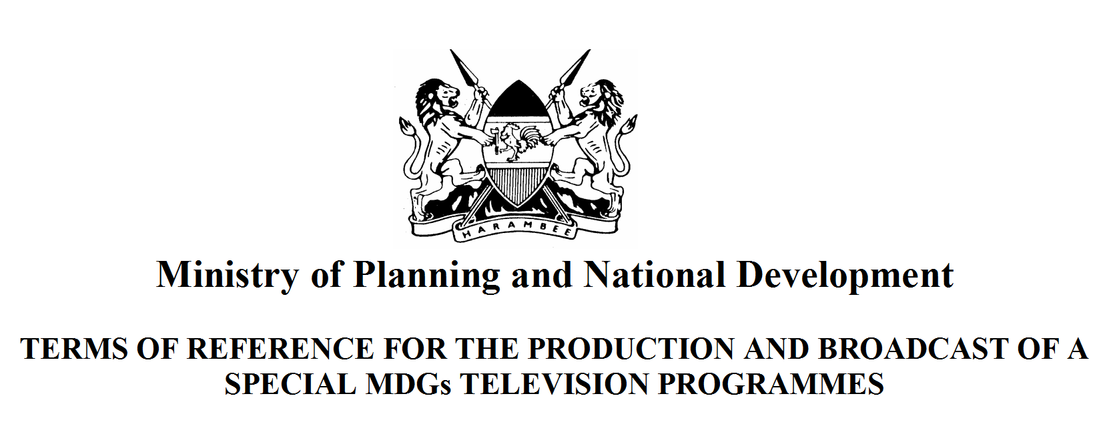

OFFICE OF THE PRIME MINISTER
MINISTRY OF STATE FOR PLANNING, NATIONAL DEVELOPMENT AND VISION 2030

Telegrams “PLANNING” Nairobi TREASURY BUILDING
Fax No: +254-(0) 20-218475 P.O.BOX 30005
Telephone: +254-(0) 252299 00100 NAIROBI GPO
When replying please quote KENYA

DATE: August 11, 2008

RE: NOTE TO EDITORS

Lawmakers, Policy Makers and Policy Implementers from the Ministry of State for Planning, National Development and Vision 2030 will meet Community Based Organisations on Wednesday 13th August 2008 from 8.30 a.m. to 1.00 p.m. at a unique forum at Pumwani Social Hall in celebration of this year’s public service week’s theme, “Citizen Service Delivery Charters” with a special focus on service delivery to communities.

The Minister of State for Planning, National Development and Vision 2030, Hon. Wycliffe Ambetsa Oparanya, will give the Opening Remarks at this Open Day Forum. He will be accompanied by the Permanent Secretary, Dr. Edward Sambili, Heads of Departments and Chief Executive Officers of all our Ministerial Semi Autonomous Government Agencies (SAGAs) which include:-
Kenya National Bureau of Statistics (KNBS)
New Partnerships for Africa’s Development (NEPAD)
Kenya Institute for Public Policy Research Analysis (KIPPRA)
National Co-ordination Agency for Population and Development (NCAPD)
Community Development Trust Fund (CDTF)
Poverty Eradication Commission (PEC)

WHAT: Presentations by the key policy making, implementing and coordinating agencies and a Question & Answers Session as the CBOs engage the Government operatives in an open discussion.

Kindly provide TV, Radio, Print and Photography coverage on this occasion.

Nancy Mathu
Public Relations Officer

